Probability

BSU - Summer Session 2017

Kari Heppner
Crookston Elementary
kariheppner@isd593.org- Grade 4

Lois Julin
Bagley Elementary
ljulin@bagley.k12.mn.us- Grade 3

Kalie Gray
Bagley Elementary
kgray@bagley.k12.mn.us- Grade 3

Executive Summary:

In the following probability lessons students will be making predictions and then analyzing and making conclusions after they collect, organize, display and represent data. The students will be placed in flexible grouping to allow maximum learning to occur.
We have created these lessons on probability to supplement our schools’ math curriculum. These lessons are based on the needs of our students and are adaptable so they are able to meet the goals and math standards of Minnesota.
Assessments are included to continue to guide our teaching and to assess the effectiveness of our instruction. After teaching we will analyze, reflect and modify. These probability lessons were created to excite students about math and learning and become twenty-first century problem solvers.

Examples of MCA (Minnesota Comprehensive Assessment) questions that students will be able to successfully answer because of this unit being taught:

Third Grade MCA Practice Question
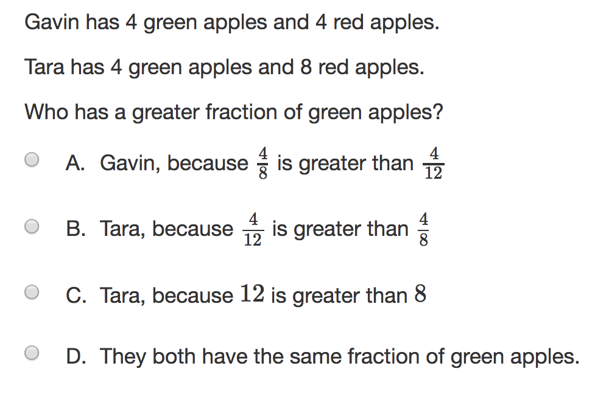

Fourth Grade MCA Practice Question
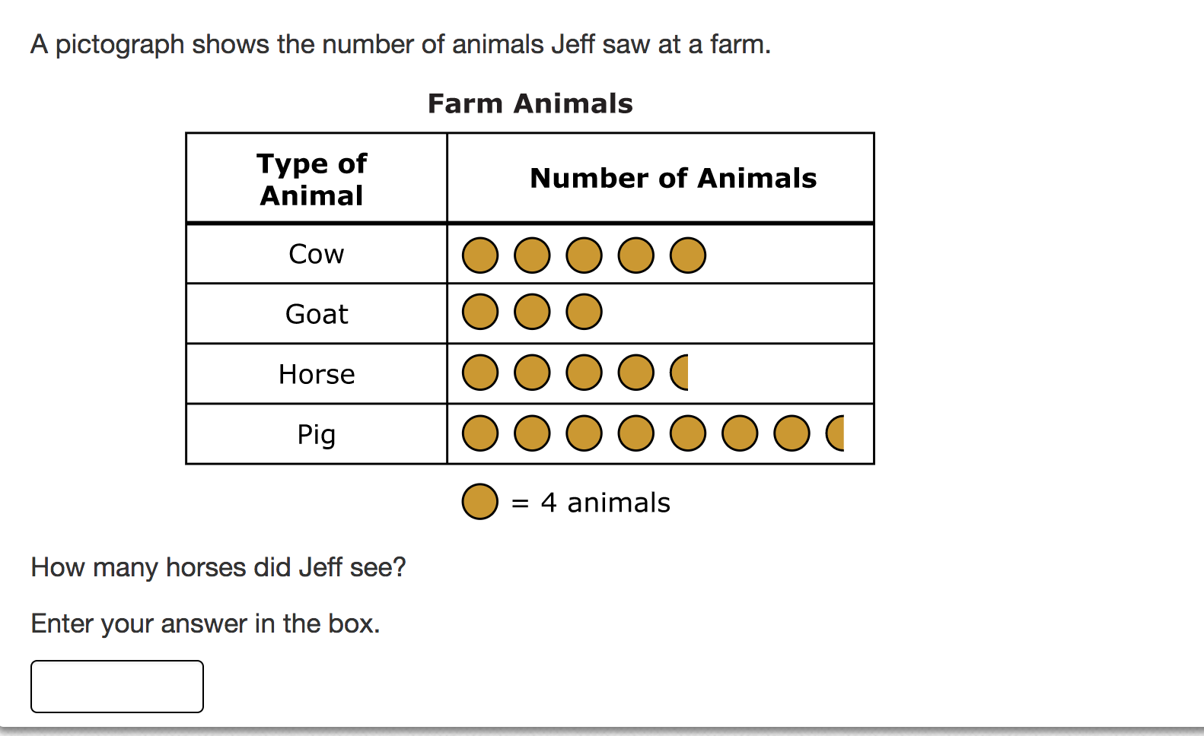

Table of Contents
Probability Pre-Test Page 5

Certain, Uncertain, Impossible Page 6-7

Shirts & Pants Page 8-10

Flip, Spin, Bang Page 11-13

Coin Flipping Page 14-15

Skunk & Pig Page 16-18

Block Grab Page 19-22

Rock, Paper, Scissors Page 23-25

M&M Math Page 26-34

Popcorn Anyone? Page 35-37

Roller Derby Page 38-41

Hare and the Tortoise Page 42-43

Whirlybird Land Page 44-48

Spinners Page 49-58

Hey, That’s Not Fair Page 59-64

Mode, Median, and Mean Page 65-69
Probability Post-Test Page 70
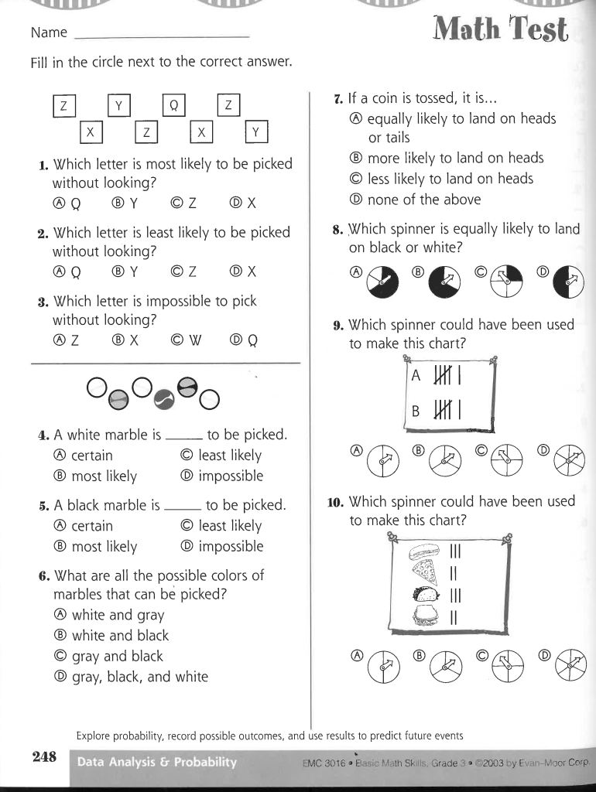

Lesson: Certain, Uncertain and Impossible/The World at Your Fingertips
Day 1

Minnesota State Standard
3.4.1.1: Collect, organize, display, and interpret data. Use labels and a variety of scales and units in displays.

Lesson Objective: Students will define and determine events that are certain, uncertain and impossible. They will also look at the probability of landing on certain areas on a globe based on a series of trials.

Launch: Give every student a sticky note. Tell them to write a statement on their sticky note that would fall under the category of certain, uncertain or impossible. When they have finished, have them put their sticky notes on the board. Now, make three category areas on the board: certain, uncertain and impossible(likely, unlikely or uncertain). Go through the sticky notes as a whole group, asking students questions about each statement to determine where the sticky note should go. Have students decide where they go and give a reason why. Discuss these categories and give other examples. Now ask them if they were to toss a globe ball around, where could their fingers land when catching the ball. Are there any certainties or uncertainties when doing this? What are your chances of landing on each of the choices mentioned? Is one way more likely than another? Tell the students that there is a (pretend) meteorite heading towards Earth, and you want to know where you and your family would be safe. The students need to figure out where that place is after they conduct a series of trials using a globe ball. Explain to the students that they are going to work in a small group, and toss the globe ball around. When they catch it, they need to look where their finger (with the red sticker or marker dot) lands. One person in each group will be recording this information every time the ball is caught. Tell them they will be looking at the data after the activity. Assign groups and send them off with red stickers and a globe ball. They will keep track on the recording page below.

Explore: Students will work in groups to record where they land on the globe ball every time they catch it. Each group should toss the ball at least 30 times. Once they have recorded their information, they will then look at their data. Each group will need to figure out where they landed the most and the least. Just using their data, they will determine where they think the safest place to be is. Also, have students report their findings to you, so you will be able to look at the numbers as a whole group. You may decide if you want them to use just land and water or use it with oceans and continents. Both pages are included.

Share: Each group will share their results from their globe ball toss. They need to have a place on the globe they think would be the safest and reasoning for why they think that, based on their data collection.

Summary: As a group, look at and determine where the safest place would be based on the whole group’s data. Compare that to what each group found. Draw their findings back to certain, uncertain and impossible (likely, unlikely or uncertain). Do any of our findings fit into one of these areas? Ask students to write one statement for each category on an exit slip. Have them label each statement with where they think it fits.

Lesson: Shirts & Pants
Day 2

Minnesota State Standard
3.4.1.1 - Collect, organize, display, and interpret data. Use labels and a variety of scales and units in displays.

Lesson Objective: Students will make all color combinations of pants and socks using patterns to sort.

Launch: Ask students, “How many of you sometimes have trouble finding clothes that match? How many of you think the washing machine or the dryer eats your favorite socks?” Allow for a few minutes of discussion. “Well today, you are going to match up some pants and shirts for Edward. I am not really sure who Edward is, but he really needs help combining clothes to see how many partial outfits he has. I say partial because you are just going to work with his socks and pants” Have a pre-colored sheet of the pants and the socks. Show the students the colored sheet of the pants and the socks. Tell them Edward will be buying shirts to match after he has figured out how many combinations he has of socks and pants.

Materials: Pg. 244 Pants and Socks Cutout of Everyday Math Masters
Pg. 188 - Dressing for the Party
Crayons or colored pencils: 1-green, 1-blue, 1-red, 1-black
Scissors
18” by 4” white construction paper
Glue Sticks

Explore: Tell students they will be making combinations or sets of pants and socks. Show them a colored page that you colored prior to this lesson. Don’t let them study it too long, just a brief glance. Tell them to make a prediction as to how many combinations they can make by pairing up the pants and socks. Have students write their first names on a scrap of paper and record their prediction on it. Collect those. Have students color their pants and socks according to the direction. Have them cut them out. Have students start making as many combinations as they can. Do not let them glue them down until they have made all the combinations. Once they are done, have them glue them down to the construction paper to use for display.

Share: Share the completed work by having students hold up their displays. Ask students if there is any other way to solve this problem. Could they have used something else? Tell students to get other materials to use to demonstrate this activity of making different combinations. Have blocks and cubes of different colors for further explorations.

Summarize: Tell students that they were able to make combinations of pants and shirts by finding a pattern to solve the problem. Put their work up for display to be able to refer to later.

Source: Bell, Max, et. al. Everyday Mathematics. Chicago:Wright Group/McGraw-Hill, 2007. Lesson 8.3 , pp. 244, 188.

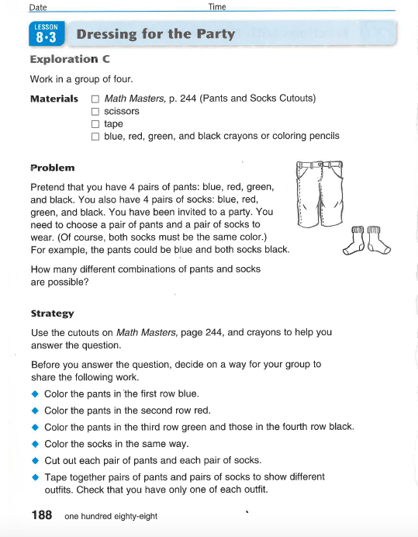
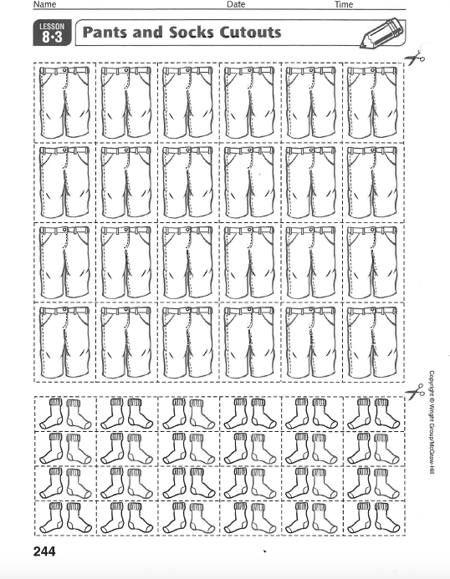
Lesson - Flip, Spin, Bang
Day 3

Minnesota State Standards
3.4.1.1 - Collect, organize, display, and interpret data. Use labels and a variety of scales and units in displays.
4.4.1.1 Collect, organize, display and interpret data, including data collected over a period of time and data represented by fractions and decimals. Use tables, bar graphs, timelines and Venn diagrams to display data sets. The data may include fractions or decimals. Understand that spreadsheet tables and graphs can be used to display data.

Objective: Students will explore chance and examine what’s fair and what’s not fair.

Launch: What’s your favorite breakfast cereal? Brock’s Mom keeps buying healthy Raisin Oats cereal for him to eat. Yuck! He hates raisins and oats. He needs your help in getting his Mom to buy the cereal he likes. He wants sugary cereal with marshmallows in it. He wants to know if coin flipping is a good way to make a deal with his Mom, but doesn’t know if he should flip, spin or bang the coin or if it even makes a difference. So let’s see if we can help Brock.

Explore: Put kids in groups of no more than 3 in a group and record their results. Discuss and analyze the results with their group. Record individual results on Excel Spreadsheet. Students will flip the coin 10 times, bang the desk while the coin balances 10 times and spin the coin 10 times.

Name _______________________________

Flipping the Coin - 10 times
Heads - Tally | Tails - Tally
Total Heads =  Fraction of Heads = | Total Tails =  Fraction of Tails

Spinning the Coin - 10 times
Heads - Tally | Tails - Tally
Total Heads=  Fraction of Heads = | Total Tails=  Fraction of Tails =

Flipping the Coin - 10 times
Heads - Tally | Tails - Tally
Total Heads =  Fraction of Heads = | Total Tails =  Fraction of Tails

Discuss results. Does this seem like a sure way for Brock to get his favorite sugar cereal Foot Loops? If so, what way should Brock use to get his cereal? Is there a for sure way for Brock to get his sugary cereal or is there a better way?

Well, he flipped the coin and lost and now he has to eat healthy Raisin Bran for another week.

Okay, Mr. Brock has come up with another plan to get his Mom to buy his favorite cereal. Since he wants sweet marshmallow cereal, he’s decided to flip marshmallows.

Explore: Students will work in partners and flip a big marshmallow 25 times making a tally for each time it lands on its side or end.

Big Marshmallow - 25 times
Side - Tally | End - Tally
Total Sides =  Fraction of Sides = | Total Ends =  Fraction of Ends =

Share: Share results from groups with whole class. So, should Brock take a chance with his Mom and make a bet to try and get the marshmallow cereal he wants for breakfast, by using the marshmallow flipping? Put individual results in Excel Spreadsheet. Discuss with your group what his bet should be.

Summary: So now, Brock makes the bet that if he flips a marshmallow, and it lands on the side, he gets his sugary cereal for the next week. Is this fair or does Brock have a better probability of getting sugary cereal? If you are to make a bet with someone, what would you use? Is it a fair way?

Lesson: Coin Flipping/How Likely Is It?
Day 4

Minnesota State Standards
3.4.1.1 - Collect, organize, display, and interpret data. Use labels and a variety of scales and units in displays.
4.4.1.1 Collect, organize, display and interpret data, including data collected over a period of time and data represented by fractions and decimals. Use tables, bar graphs, timelines and Venn diagrams to display data sets. The data may include fractions or decimals. Understand that spreadsheet tables and graphs can be used to display data.

Objective: Students will explore probability and chance and determine if the activity is “fair”.

Launch: Have students vote on whether they think coin flipping is fair or not. Is this a way you would figure something out with a friend? Why or why not? Explain that today the students will flip coins and record their findings. For each day on the calendar provided you will flip a coin once and record what you flipped. Then you need to figure out the percent of the times you flipped heads. You do this as you go. Walk through a few examples with the students to help them understand this part. Have students work in partners on this activity. Hand out labsheet 1.1A for recording their data. Also, labsheet 1.1B is attached for the students to graph their data as well.

Explore: In pairs, students will flip coins and record their data on their lab sheet. They will also look at the percent of time heads was flipped. After they finish this, they will graph their data. At that point, they need to come to a conclusion based on their data, to determine if coin flipping is “fair” or “not fair”. They also need to explain why they have reached this conclusion. Each pair will share with the class.

Summary: Ask students to vote now, based on class data, on whether they feel coin flipping is fair or not. Tell students they have based their decision on experimental probability. They actually did an experiment and looked at the data they recorded to reach a conclusion. Is this a way you would solve something with your friends now?

Lesson: PIG and SKUNK
Day 5

Minnesota State Standards
3.4.1.1 - Collect, organize, display, and interpret data. Use labels and a variety of scales and units in displays.
4.4.1.1 Collect, organize, display and interpret data, including data collected over a period of time and data represented by fractions and decimals. Use tables, bar graphs, timelines and Venn diagrams to display data sets. The data may include fractions or decimals. Understand that spreadsheet tables and graphs can be used to display data.

Objective: Students will practice mental addition facts and look at patterns strategically and discuss probability and luck. They will learn how to play PIG and SKUNK.

Launch: Today we’re going to learn a new game and find out if it takes strategy or luck to win. The name of the game is PIG, you need to know a little about probability as well as not being too much of a pig. What is the probability of throwing one 1? What is the probability of throwing snake eyes (two 1’s)

Materials: 2 dice, a paper and pencil (to help you add)

Directions: You roll the dice and add up what they say. The idea is to get to 100. You don’t have to take turns. You keep rolling as long as you want. BUT: If a 1 comes up on 1 of the dice, you lose your count for that turn.
If a 1 comes up on both dice, your total goes back to 0. (Even if you were at 98!) And anytime you throw a 1, you lose your turn. Play a practice round with he class.

Explore: Now play with your partner.

Share: Who won and how many turns did it take? Is there a strategy to winning? If you’re a PIG (greedy) do you lose?

End with a class game of Skunk. The students stand up and the teacher rolls the dice while the students add the sum of the two. If you sit down before a 1 is rolled, you get the points on the board for when you sat down. If two 1’s are rolled, all the students still standing lose all their points while the students sitting don’t lose any points. If only one “1” is rolled the students standing only lose the points from that roll.

Summary: Today we learned about luck and probability. Which game did you enjoy more? . When we roll dice is it a certainty that a one will eventually show up? Tonight teach someone at home how to play this game. Ask them if it takes skill or if it’s just luck to win a game.

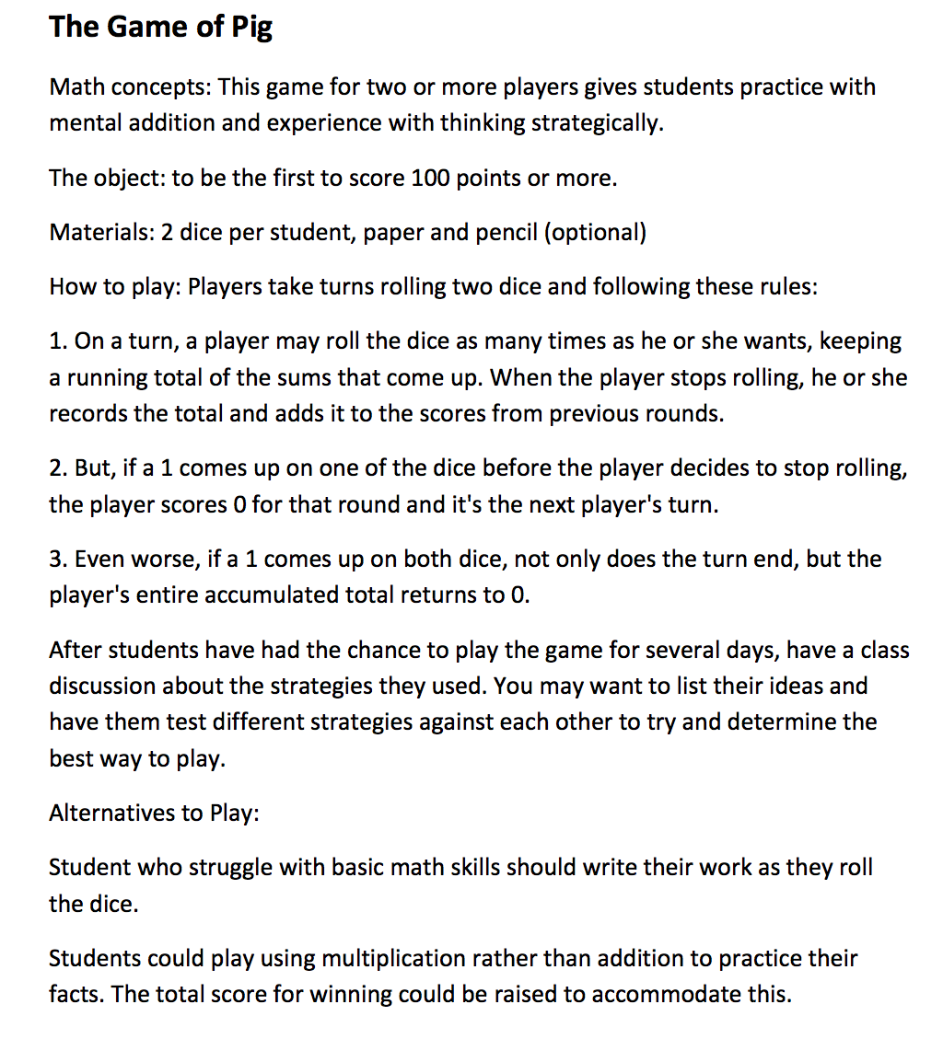

Lesson: Block Grab
Day 6

MN State Standard
3.4.1.1 - Collect, organize, display, and interpret data. Use labels and a variety of scales and units in displays

Lesson Objective: Students will explore chance and examine “fairness”.

Launch: Ask students what they think is fair in a game. Ask them if they had one arm tied behind their back and you’re “it” in a game of tag, would it be fair to play that way? Ask them what kinds of board games do they like? Do they use spinners or dice? Do they use something else? Ask students is it fair to use dice, or cards, or a spinner to help make a choice in a game? After a discussion of what is fair in a game, tell students they are going to play a game called, It’s In the Bag. Show them the bag. Shake it so they can tell there is something in the bag. Tell them it has some colored blocks inside. Draw one block out at a time - one red, one green, and two blue ones. Ask: How many blocks do you see? How many different colors do you see? Put them back in the bag. Ask the following questions:

- What color do you think I will probably pull out? Why?
- Does each color have an equally likely chance of being pulled from the bag? Why or why not?
- How could we make this activity one with equally likely outcomes?
- Can you describe a certain (clarify certain) event, using these blocks? (Pull a counter from the bag.)
- How about an impossible (clarify impossible) event using the blocks? (Pull a brown, or some other color, block).
- What fraction of the blocks is green?
- What fraction of the blocks is red?
- What fraction of the blocks is blue?
Record this information on the whiteboard. Be sure not to include the brown, or other color block.

Materials: Brown bags, one for each group
1 set of blocks, 1 red, 1 green, 2 blue
Tally sheets labeled: Red, Green, Blue (or students make one)
Pencils
Spreadsheet labeled: Group Name, Prediction/Most, Actual/Most

Explore: Group students into groups of three. Tell them to come up with some kind of name for their group such as The Bears, etc. Record that information on a spreadsheet. See the example. Give each small group a paper bag and one red, one green, and two blue blocks. Within each group have one student hold the bag, another pull out the blocks, and another keep a record of what color was selected. Before each group begins the experiment, ask the students to predict which color will be selected most often in twenty (20) pulls. Record the groups’ predictions in a spreadsheet so they can compare the actual with the predicted.

Example of the first spreadsheet for It’s In the Bag
Group Name | Prediction/Most | Actual/Most - 1st Round

Then ask the students to select a block from their bag, making sure that the recorder tallies the color selected. The block is then returned to the bag, which is shaken before another block is selected. This sequence should be repeated twenty times.
Example of the second spreadsheet/tally sheet for It’s In the Bag

Names of Group:
 | Red | Green | Blue
Round #1

Students could write this out for themselves on scratch paper or the teacher can make one, print it, and give it to the students. The teacher could use this as a spreadsheet to make final tallies and to be used to compare rounds.

Share: Groups will share their completed tallies with the class. They will give their findings to the teacher to put on the Actual/Most. Ask each group the following questions:
- Which color was selected that most? The least?
- Did you expect this result? Why or why not?
- Was the number of blue blocks selected close to one-half of the total selected?
- Was it possible to pull a red block from the bag? Why?
- Was it possible to pull a black block from the bag? Why not?
- (Challenge question) if you pulled a counter from the bag 100 times, how many times would you expect to select a blue block? A red block?
- Was your method of completing the activity consistent - did the “shaker” always shake the bag between pulls, did the “puller” always select the block in a certain way?

Ask students, “Was this fair? Why or why not? What would you do differently, or would you even change it?”

Repeat this activity and keep all the recorded information. As you add to the first spreadsheet, you will be able to compare with the first round. Maybe play three to five times, to switch rolls of the students, and to get more data collected.

Summarize: Tell students they were learning about chance and examining what “fairness” might mean.

Lesson: Rock Paper Scissors
Day 7

Minnesota State Standards
3.4.1.1 - Collect, organize, display, and interpret data. Use labels and a variety of scales and units in displays.
4.4.1.1 Collect, organize, display and interpret data, including data collected over a period of time and data represented by fractions and decimals. Use tables, bar graphs, timelines and Venn diagrams to display data sets. The data may include fractions or decimals. Understand that spreadsheet tables and graphs can be used to display data.

Objective: Students will play Rock, Paper Scissors in a few different ways, as well as a twist with money, and look at the fairness and if a strategy is involved in playing the game.

Launch: “Now let’s have a little competition. Do you know the game Rock, Paper, Scissors? (Discuss) Two people face each other and say ‘Rock, Paper, Scissors,’ then each puts out a hand shaped like one of those three things. Rock beats scissors because it can smash them; scissors beat paper because they cut it; and paper beats rock since it can wrap around it. So any item can win or lose. How do we start? “Rock, Paper, Scissors, Go.” Do you think there’s a strategy to this game or is it just luck? Discuss with your partner. Now, let’s play and find out what you think after the game , but this time let’s take score. Write down your name and every time you win you get a point.

Explore: Play “Rock, Paper, Scissors.” After they’ve played for a little while, ask again if they think strategy is involved, if it’s fair or it’s just luck and why?

Explain: How many of you have played this game with 3 people. Well today we’re going to learn a new way to play. Put students into groups of 3. Now, decide who is A, who is B and who is C. Okay, all the A’s in the group raise your hand, all the B’s in the group raise your hand and all the C’s in the group raise your hand.

If you’re an A you’ll get a point if all three of you put out the same objects. For example if all of you put out a rock A gets a point.

If you’re a B, you’ll get a point if all of you put out a different object. For example, Ava puts out a scissor, Ethan puts out a rock and Ada puts out paper, then B gets a point.

If you’re a C you’ll get a point if 2 objects are the same and one is different. For example, Tristan puts out a rock, Adelia puts out a rock and Hallie puts out a scissors, then C gets a point.

Do you think this sounds fair? Why or why not? Discuss with your group of three.
Have them play and then ask them the same question if the game was fair?

Make a table like the one below with the students help.

3 Same | 3 Different | 2 Same 1 Different
RRR  PPP  SSS | RPS  PSR  RSP  PRS  SPR  SRP | RRP SSP PPS  RRS SSR PPR  RPR SPS PSP  RSR SRS PRP  RSS SRR PRR  RPP SPP PSS
3/27 | 6/27 | 18/27

If time allows for another variety.
We’re going to do play Rock, Paper, Scissors today with coins: each coin beats out a coin worth less, EXCEPT pennies beat quarters! ” 1. Pair off the kids. Give each kid 1 of each coin: quarter, dime, nickel, penny. 2. Each player secretly chooses 1 of the 4 coins and hides it inside his/her fist. 3. Each pair of players faces each other and says “Penny, nickel, dime, quarter!” while pumping their fists. Then they both put out their open hand to show the coin chosen. 4. The winner gets to keep both coins. The winner is the player who has the higher value coin EXCEPT when it’s a penny paired with a quarter, in which case the penny wins. In the case of a tie, players put the tied coins back in their unused pile and try again. If that’s the last coin to play, each player keeps his/her coin and the game ends. 5. After players have used all their coins, ask the kids: ★ “How many pairs of players came out even?” ★ “Why can the 2 players not come out even when you start with the same coins?” Discuss! 6. If there’s time and interest, kids can play another round. Bonus (optional): Ask the kids: “What are your chances of winning all 4 times?” Kids can wrangle with the different scenarios for each coin. They need to find the chance of each coin winning, then multiply those fractions by each other to get the total chances. The P and N each have ¼ chance, the D and Q each have ½ chance. ¼ x ¼ x ½ x ½ = 1/64th!

Summary: So are games always fair? Which one of these versions of Rock, Paper, Scissors did you think was the most fair and why?

Lesson: M&M Math/Probability
Day 8

Minnesota State Standards
3.4.1.1 - Collect, organize, display, and interpret data. Use labels and a variety of scales and units in displays.
4.4.1.1 Collect, organize, display and interpret data, including data collected over a period of time and data represented by fractions and decimals. Use tables, bar graphs, timelines and Venn diagrams to display data sets. The data may include fractions or decimals. Understand that spreadsheet tables and graphs can be used to display data.

Objective: Students will use probability when looking at bags of M&M’s. (You can also use Valentine Heart candy to do something similar-papers included)

Launch: What is your favorite color of M&Ms? How often do you get that color when you eat M&M’s? I wonder if there is a way to figure out what the chance is of getting your favorite color. What do you think? How could we do that? Allow students to give ideas and discuss this idea. Explain that today they will be making estimates of how many M&M’s they think are in their bag and how many of those are yellow, green, blue, red, brown or orange. They do the estimation first. After they have recorded that information, they will open their bag of M&M’s. They will count and record the total amount of M&M’s in the bag. Then they will sort the M&M’s by color and record how many there are of every color. They will compare their estimates with the actual outcome. They also will graph their data. They will find the probability of getting each color in a bag of M&M’s. (A pictograph is attached as well if you wanted to use it.)

Explore: Students will make predictions and share them with a partner. Then they will open, count and sort their bag of M&M’s. They will graph their data. After they have finished, they will compare their data with their partner. Each partner does their own bag and recording. As a pair, they will determine how likely it is to get each color of M&M.

Share: After they have worked with their partner, the pairs will share their data with the class. As a class then, you will find the whole group probability of getting each color of M&M in a bag.

Summary: Do you have a good chance of getting your favorite color of M&M in your bag? Why or why not? Tell the students that they have used M&M’s today as a math tool in an experiment to collect data. Now they get to enjoy the taste of them!!

Sources: M&M Graphing by Jennifer Tice @ Rowdy in First Grade.

M&M Estimation: Name:___________________

How many M&M’s do you estimate are in your bag?________________________

How many red M&M’s do you estimate there are?______________________

How many yellow M&M’s do you estimate there are?_____________________

How many orange M&M’s do you estimate there are?_____________________

How many blue M&M’s do you estimate there are?______________________

How many green M&M’s do you estimate there are?_____________________

How many brown M&M’s do you estimate there are?_____________________

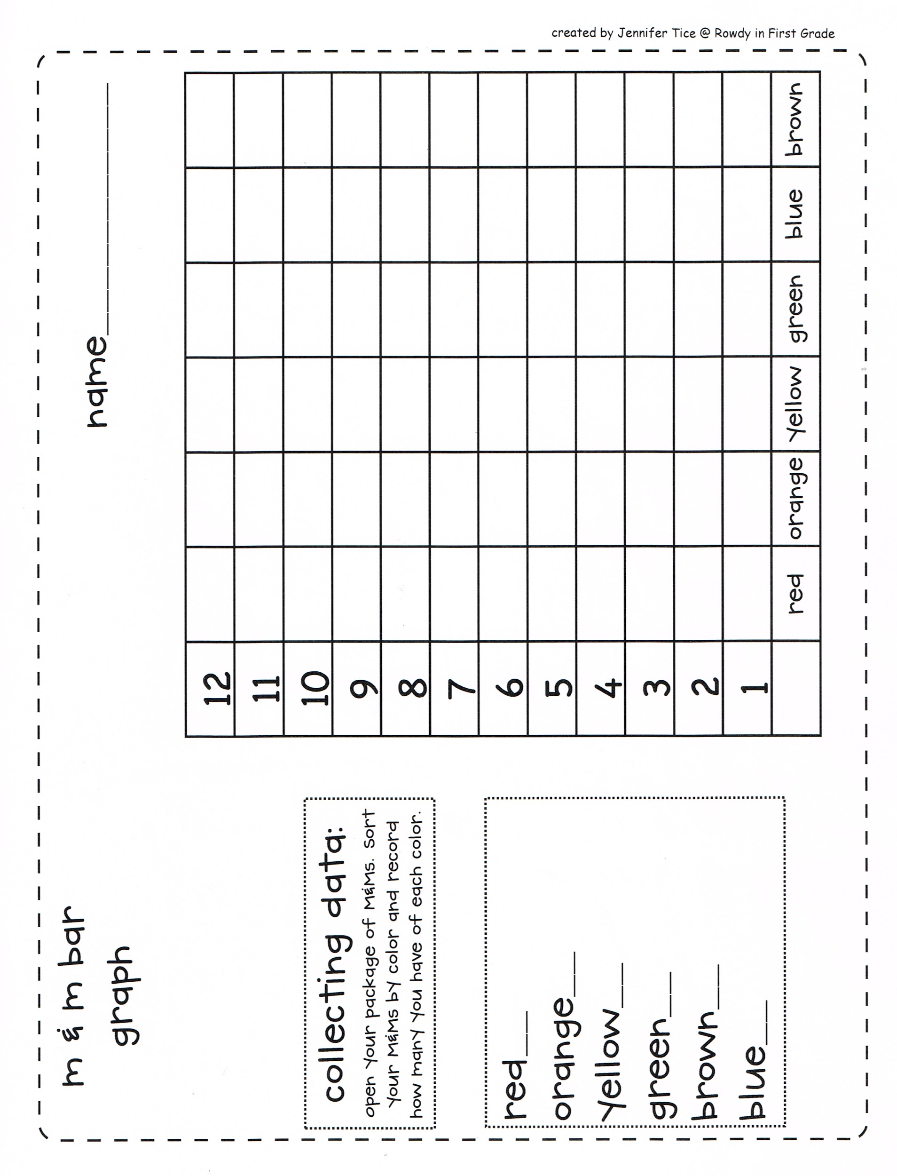

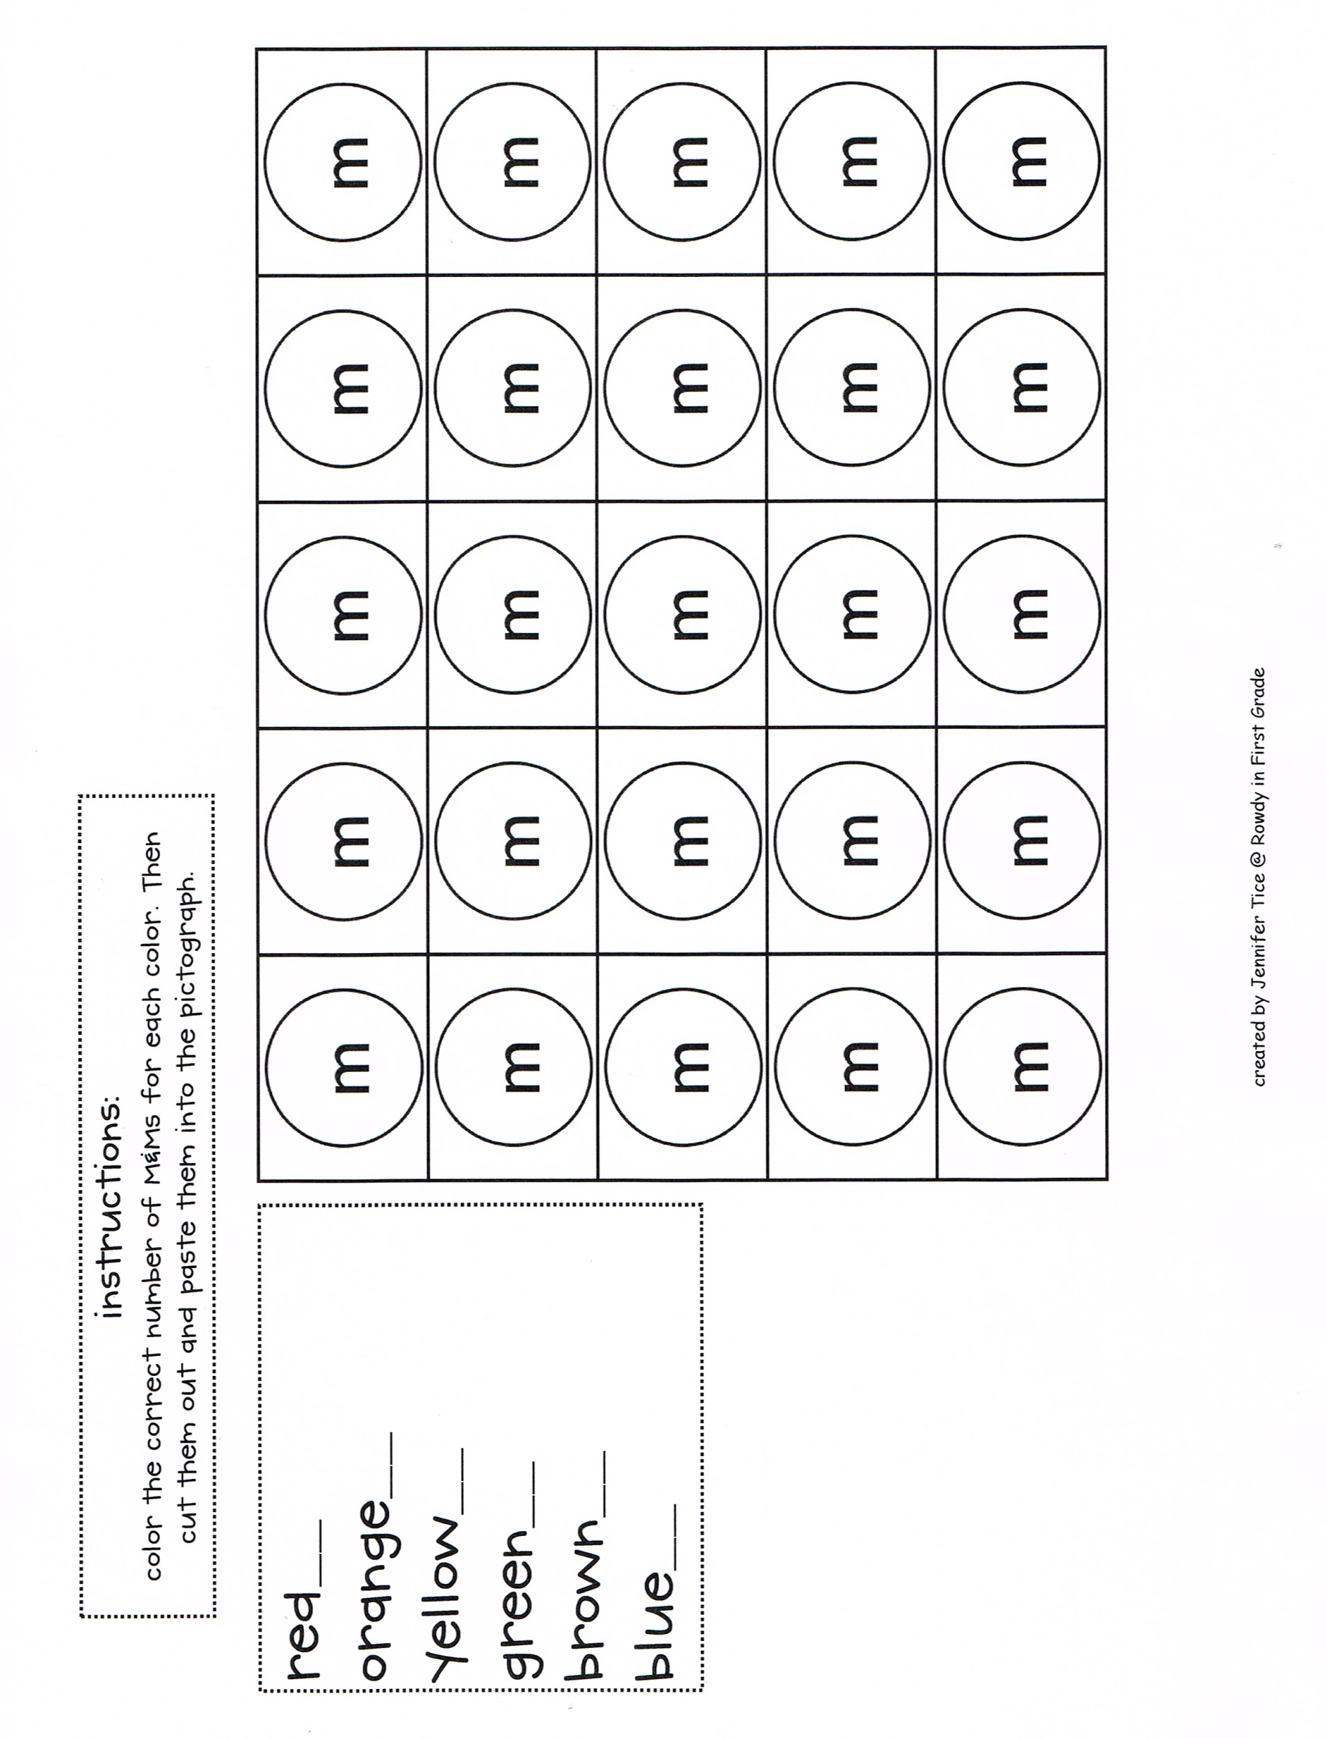

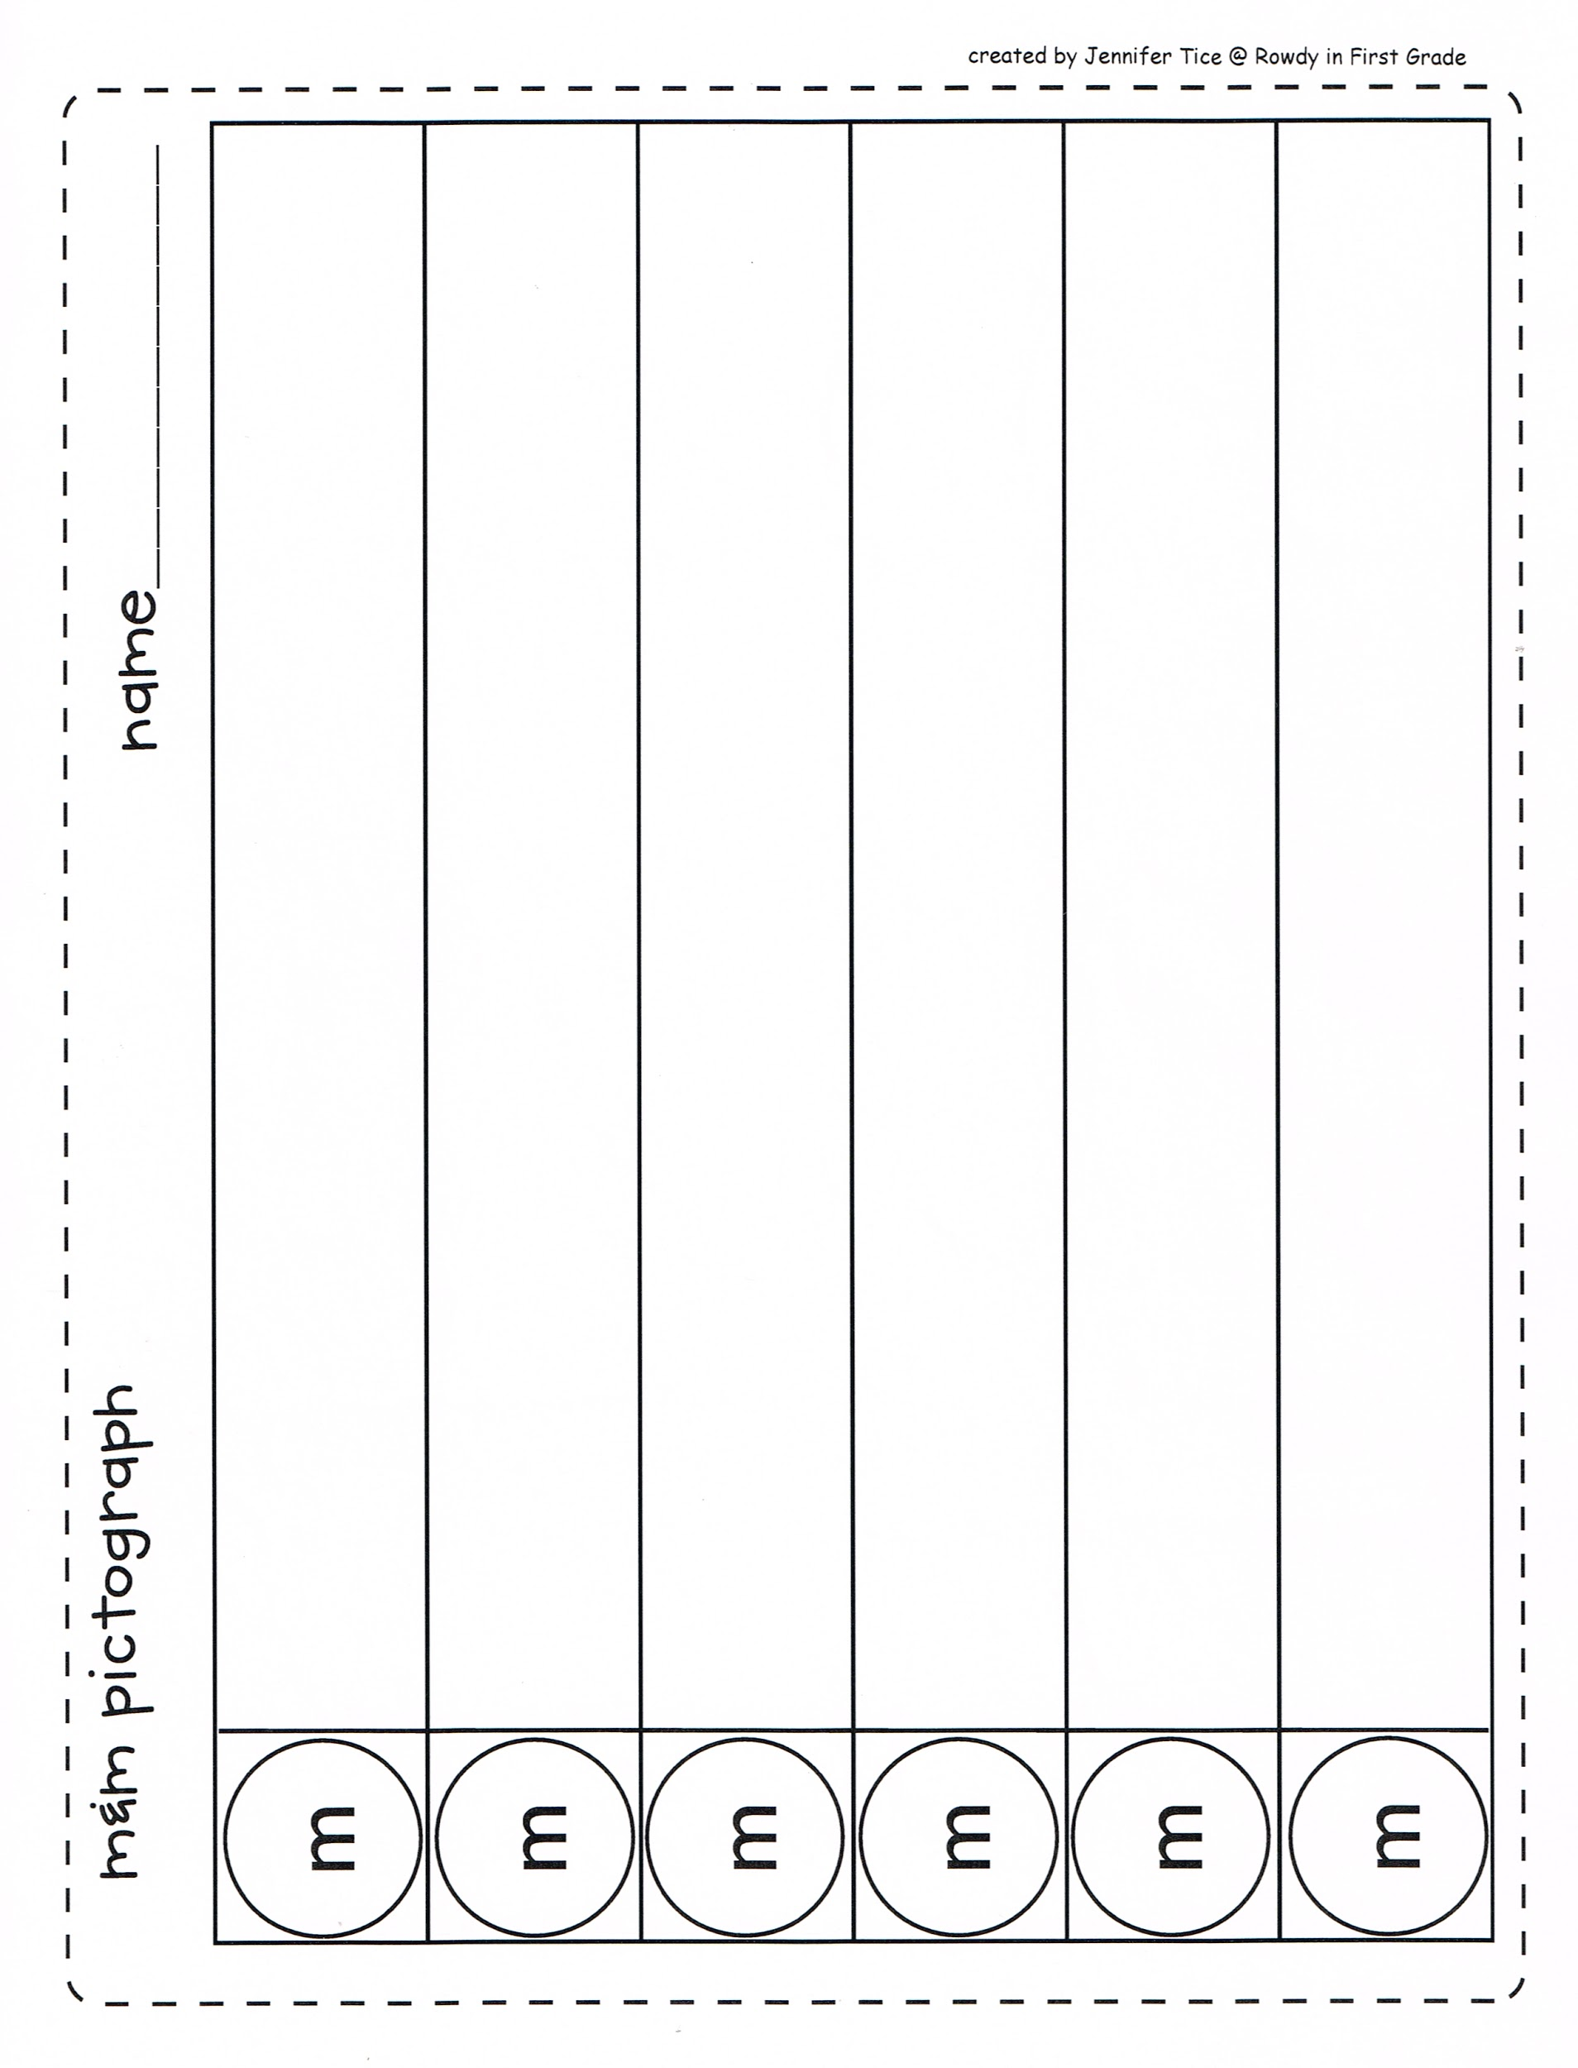
Name:_________________________________

M&M Math Probability

What is the actual probability of getting each of the colors based on your bag of M&M’s?

-RED:_________________

-YELLOW:_______________

-ORANGE:_________________

-BLUE:___________________

-GREEN:__________________

-BROWN:__________________
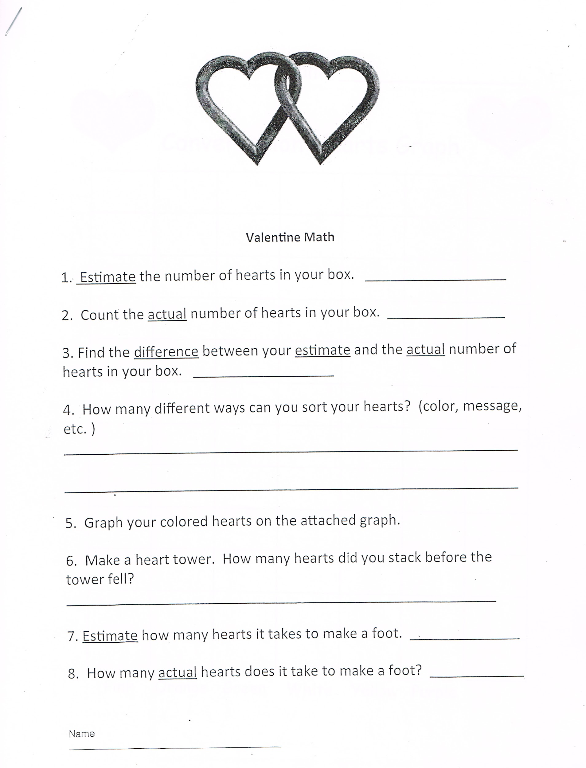

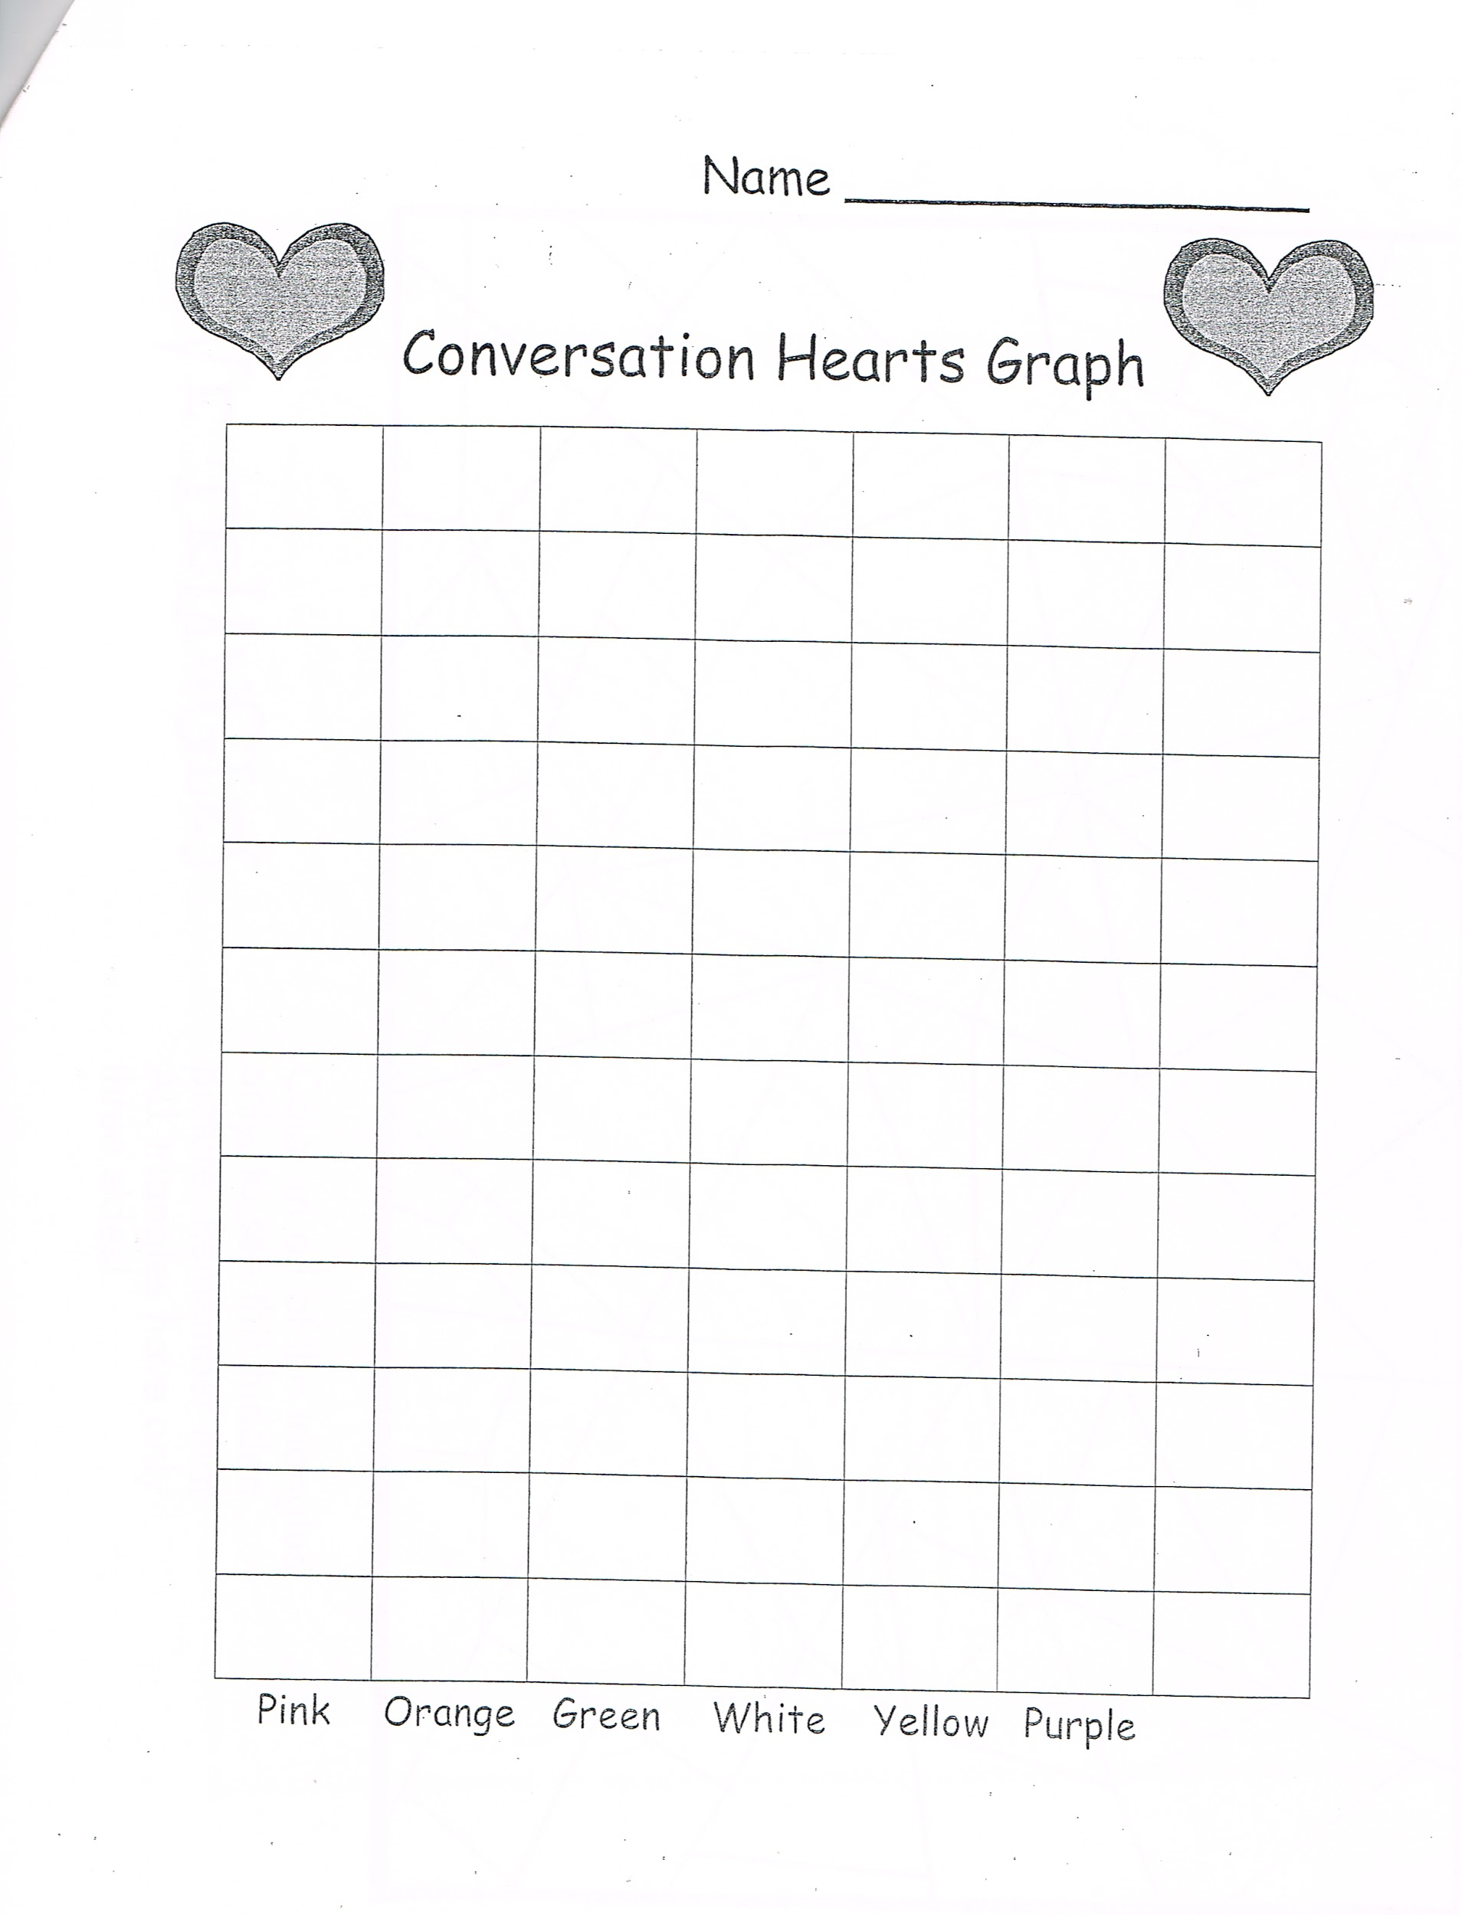

Lesson: Popcorn Anyone?
Day 9

Minnesota State Standards
3.4.1.1 - Collect, organize, display, and interpret data. Use labels and a variety of scales and units in displays.
4.4.1.1 Collect, organize, display and interpret data, including data collected over a period of time and data represented by fractions and decimals. Use tables, bar graphs, timelines and Venn diagrams to display data sets. The data may include fractions or decimals. Understand that spreadsheet tables and graphs can be used to display data.

Objective: Students will compare the volume of 2 cylinders by using the same size sheets of paper and construct 2 different cylinders. As a class, they will predict which cylinder will hold more and then through experimenting observe which cyclinder holds more and why.

Launch: “Popcorn, get your popcorn here! Who loves popcorn? Anyone want a container of popcorn? I have 2 containers for popcorn, but unfortunately you can only have one. You’re going to be watching an awesome movie tonight and want the biggest box of popcorn. Show the two cyclinders. Which cylinder do you think you’d like to fill with popcorn? Those of you who think it doesn’t matter and the two cylinders will hold the same amount, raise your hand. Those of you who think the long cylinder, (hot dog style) holds more raise your hand. Those of you who think the shorter cylinder (hamburger style) holds more, raise your hand.
Well lets find out?

Explore: Put students in groups of two, give them 2 sheets of 8.5 X 11 in paper, one white and one colored. Give them them the exploration sheet below.

Popcorn Anyone?
Exploration Activity
Name __________________________
For this activity you will be comparing the volume of 2 cylinders created by you using the same size paper. You will determine which cylinder can hold more popcorn or if they both hold equal amounts.

Materials:
8.5 X 11 in. white paper popcorn
8.5 X 11 in. colored paper paper plate
Tape

Directions:
- Take the white paper and roll it up along the longest side to form a baseless cylinder that is tall and narrow (hot dog roll). Tape it without overlapping any paper.
- Now take the colored sheet of paper and roll it along the shorter side to form a baseless cylinder that is short and stout (hamburger roll). Tape it along the edge without overlapping any paper.

Now record your prediction:
Do you think the two cylinders will hold the same amount of popcorn? ____
Do you one cylinder will hold more than than the other? ___________
Which cylinder will hold more? __________________
Why?

Fill white cylinder with popcorn. Now dump it out. How many kernels did it take to fill the white cyclinder (hot dog roll) _______________kernels.

Fill the colored cylinder with popcorn. Now dump it out. How many kernels did it take to fill the colored cylinder? _____________________________
Why is this possible? _________________________________________
Would there be an easier way to measure which cylinder holds more popcorn?

Share: Students share their results of the popcorn challenge and give a theory of their findings. Increasing the diameter, increased the volume more than increasing the height. . Watch video of Dan Meyer ttps://www.youtube.com/watch?v=mH0QLSffq0c

Summarize: Today we learned that volume of an object can’t be based on what you think is bigger but rather you have to go by the diameter of the cylinder. Now what cylinder would you pick for your popcorn container?

Lesson: Roller Derby
Day 10

MN State Standard 3.4.1.1 - Collect, organize, display, and interpret data. Use labels and a variety of scales and units in displays.

Lesson Objective: Students will analyze the results of a game and choose a strategy to play. Students will collect patterns of the dice as they roll.

Launch: Ask students, “Anyone run a good race lately? Got any tips for us that helped you when you ran?” Allow for a few minutes of discussion. Tell students they will be playing a game that will help them choose a strategy that might help them win.

Materials: Gameboard
Beans, or other type of marker, 12 per player
Dice
Dice data collection sheet
Pencils

Explore: Tell students they will be playing Roller Derby, a game of strategy. Show students the game board. Tell them they will each get 12 beans to put into any of the columns they choose. Explain that the first person rolls the dice and removes the corresponding bean from that column. If there is no bean, that person loses his turn. It is the next person’s turn. The first person to remove all their beans wins the game. Pair students up and give them the supplies they need to play the game, a pair of dice, a game board, and the beans. Tell them to play rock, paper, scissors to decide who gets to go first. Have the students play the game the first time through. The teacher will walk around the room and observe the students as they play. Watch for their strategies as to how they place the beans.

During the second time the students play the game, tell them to keep track of the numbers they roll on the dice with tallies. Use a tally sheet similar to the one attached for them to record on. Tell them they will be using this tally sheet for the third game to collect the dice rolls. They will use this information to compare both rounds of their second and third games.

Share: Have students share what strategy they used to place the beans on their Roller Derby mat. Have them share why they changed their strategies, if they did at all. What did they notice during the game? Tell them to look at their tally sheets. Ask them, “What do you notice?” Ask students what numbers were more likely to occur than others. Have them share their information with you from their tally sheets to put into a spreadsheet. Show this on the smartboard. Now ask them, “What do you notice?” Ask students what sums are possible when you roll two number cubes? Ask how many ways can you get a 6? Ask them if it is more likely they will get a 6 than a 2. Talk about their responses. If time, list the combinations students can get with the dice.

Summarize: Tell the students they used a strategy to place their beans at the beginning of the game based on their experiences while playing the first couple of games. Tell them they saw a pattern for how the beans were removed. Tell them they saw a couple of numbers that showed up more often than the others.

Dice data collection sheet
Tally sheet

Roll of Dice Tallies

Second Game Third Game
1
2
3
4
5
6
7
8
9
10
11
12

Source: Investigations, pp. 42 - 43, 48, Lesson 5.1

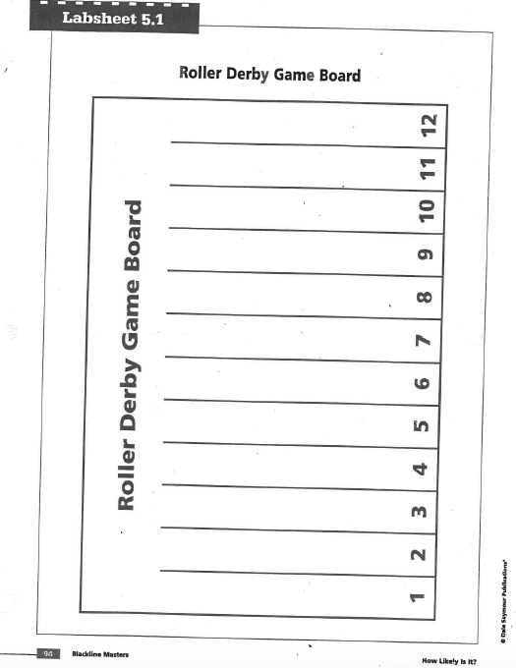

Lesson: The Hare and the Tortoise Game/Addition Dice Roll
Day 11

Minnesota State Standards
3.4.1.1 - Collect, organize, display, and interpret data. Use labels and a variety of scales and units in displays.
4.4.1.1 Collect, organize, display and interpret data, including data collected over a period of time and data represented by fractions and decimals. Use tables, bar graphs, timelines and Venn diagrams to display data sets. The data may include fractions or decimals. Understand that spreadsheet tables and graphs can be used to display data.

Objective: Students will look at and use probability while playing a game. They will also look at even and odd numbers.

Launch: Read the story The Tortoise and the Hare by Jerry Pinkney. Ask the students about who won and why. Is that what they would have expected?Tell them that today they are going to play a game called The Tortoise and the Hare. Explain the game to them (directions attached to the record sheet). They will each have 16 turns to roll the die. After they finish the game, they will tally up their totals for each letter they landed on. They will then look at the probability of landing on each letter based on their data from their game. They will also be working with even and odd numbers.

Explore: Students will get their record sheet with the game board, a die for each partner and a marker to use as you move on the game board. They will then choose a partner and begin playing the game. As a pair, they will each fill in their record sheet and work together to find the probability of landing on each of the letters, using their game data.

Part 2: (If time allows)
Explore: Addition Dice Roll
Students will roll two dice, one person at a time. Add the dice together and color in the space next to that number on the grid. Then let your partner have a turn. Keep playing until one row is filled. After the game is finished, have the students think about what the graph looks like, which sum was rolled most and least and what the probability of rolling each sum would be. Have them pair up with one other group and compare/ share graphs and data. Have them look at even and odd numbers. Are there any patterns that they noticed?

Share: Each pair will share their data by writing their probabilities on the board. Each pair will have a turn to explain their data. Ask the students what they found by playing this game. Was this a fair game? Why or why not. Allow time for students to discuss their findings and reasoning. Explain that as they played the game, they started to notice things that led to their conclusions.

Summary: Explain to students that they used probability while playing the game and ask what were the patterns you noticed when adding even or odd numbers.

Lesson: Whirlybird Land
Day 12

Minnesota State Standards
3.4.1.1 - Collect, organize, display, and interpret data. Use labels and a variety of scales and units in displays.
4.4.1.1 Collect, organize, display and interpret data, including data collected over a period of time and data represented by fractions and decimals. Use tables, bar graphs, timelines and Venn diagrams to display data sets. The data may include fractions or decimals. Understand that spreadsheet tables and graphs can be used to display data.

Objective: Students will investigate, analyze, organize and make conclusions about data from a parachute jump competition.

Launch: What is a parachutist? How many of you would like to be one? Parachutists have competitions in which they try to land as close as they can to a target. You and your partner will simulate a parachute jump by dropping a whirlybird. You and your partner are going to make a whirlybird and drop it to test its spin. You will have to adjust the spin if necessary. How close can you come to the target? Can you come close almost every time?

Explore: Provide pairs of students with the pattern and directions for making a Whirlybird. Use the Blackline Master 16, below. Whirlybirds can also be cut from large index cards. Each pair needs one whirlybird, but each student may want to make his own. Tell students that the whirlybird should spin as it descends. If it doesn’t spin, students should adjust the angle of the wings before beginning the experiment.

Have pairs place a self-stick dot or cutout circle on the floor as a target. Before beginning the test, have student pairs create or give them a five column table for keeping track of the drops like the one below.

Sample Chart:
Distance from the target (cm) | Tally | Frequency
0 |  | 0
1 - 10 | l l l l | 4
11 - 20 | l l l l | 4
21 - 30 | l l l | 3
31 - 40 | l l l l | 4
41 - 50 | l l l | 3
51 - 60 | l l | 2

Step 1. Before beginning, record a prediction for which distance range will have the most hits.

Step 2. Hold the whirlybird at shoulder height, aim it to hit the target, and let it drop.

Step 3. Using a metric tape measure or ruler, measure in centimeters the distance from the point at the end of the whirlybird to the target.

Step 4. Record the measurement in the Tally column of the table.

Step 5. Take turns dropping the whirlybird and measuring and recording its position until you and your partner have made a combined total of 10 drops.

Step 6. Based on the results of the first 10 drops, adjust the predictions made earlier and repeat 10 more times for a total of 20 drops.

Questions to help analyze data and formulate a solution. Use the sample chart above to answers the questions as a class and do their own data on their own.
How many drops are a direct hit (or 0 cm)? How many hit within 1-10 cm?
11 - 20 cm? 21 - 30 cm?
We can define “on target” as on or near the target. Is 0-20 cm reasonable as an on-target hit? Why or why not?

How many drops hit within 0-20 cm?

Add a fourth column labeled Cumulative Frequency at the top of the fourth column. The cumulative frequency is the accumulated total number of entries across the intervals, beginning with zero. Cumulative frequency is necessary in making statements that combine several intervals. This also allows student to make percentage statements about data.

Summary - Make Statements like these:

Eleven of the 20 drops were within the 0-30 cm range.
Nine of the 20 drops were in the 31-60 cm range.
Nearly half of the drops landed at the greater distances from the target.

Make a class data table like the one below and see where the greatest drop occurs. Drop it in front of the class and tell them that even though the greatest drop occurs in a certain area you don’t know which drop will occur there.

This lesson may also be tied in with a STEM lesson entitled Geronimo! Found at the website: http://www.siemensscienceday.com/pdf/geronimo

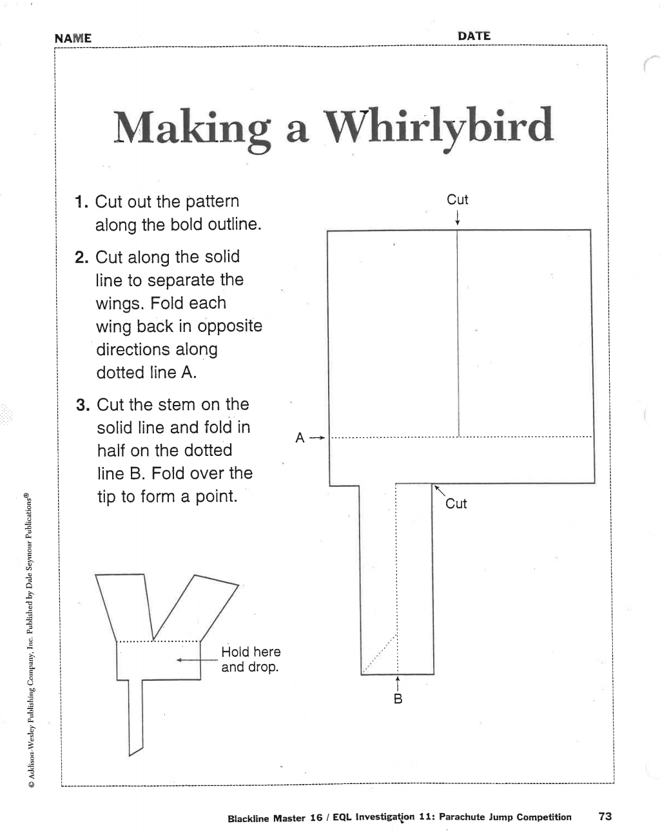

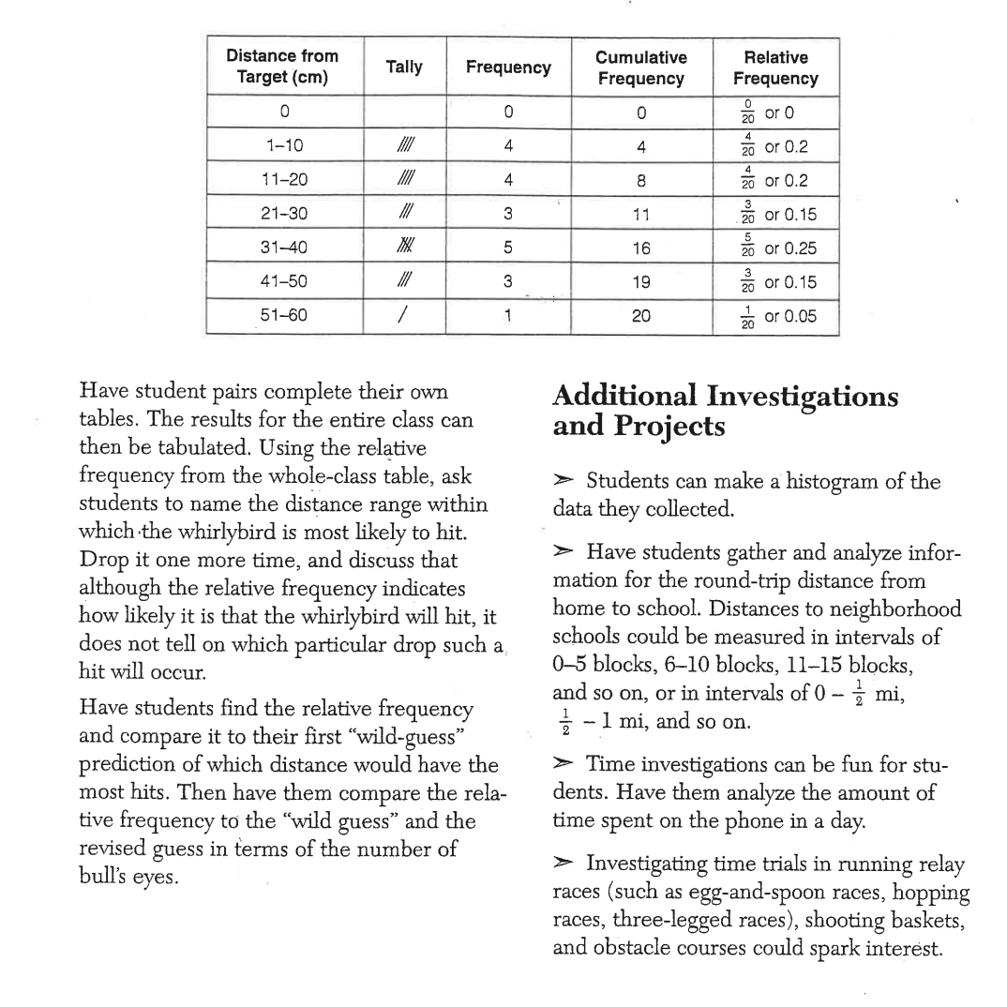

Lesson: Spinners/ Scoring Options Game
Day 13

Minnesota State Standards
3.4.1.1 - Collect, organize, display, and interpret data. Use labels and a variety of scales and units in displays.
4.4.1.1 Collect, organize, display and interpret data, including data collected over a period of time and data represented by fractions and decimals. Use tables, bar graphs, timelines and Venn diagrams to display data sets. The data may include fractions or decimals. Understand that spreadsheet tables and graphs can be used to display data.

Objective: Students will use what they know about probability and how to make wise choices while playing a game. They will look at the probability of each event, and see which is most likely and least likely to happen.

Launch: Raise your hand if you have ever taken a chance before. Now raise your hand if you have ever used skills to do something. Well, today you get to do both. You are going to be playing a game that takes both chance and skill to play. Show students the game template and a spinner. Walk through the directions of the game (see attached) and review key vocabulary. Explain that they need to look at the choices and choose the best two options to land on. Tell the students that is where their strategy comes in. Walk through a few examples on the game sheet with them before you send them off to play. Also show them how to score. Examples of vocabulary to review would be multiple, factor, digit, odd and even. Leave examples of these on the board for reference. They are trying to get as many points as possible. They will spin 20 times in all.

Explore: Students will work in pairs. After they finish playing the first game, have a class discussion about what they saw and what they used as their strategy. Give them the second sheet when they are ready for playing another game. You may also have a blank game sheet available for those students that finish quickly and are able to create their own options for a game. If two pairs finish this, they may exchange game sheets and play each other’s games.

Share: Have pairs of students partner up with another pair and discuss what they found when they played the game. What strategies did they use? Did they work? Why or why not? How might you change it the next time? Allow time for a few students to share with the whole group.

Summary: Tell the students they used strategy, skill and took chance in order to play the game today. Ask them how this game might help them in another area in their life by using strategies and skill.

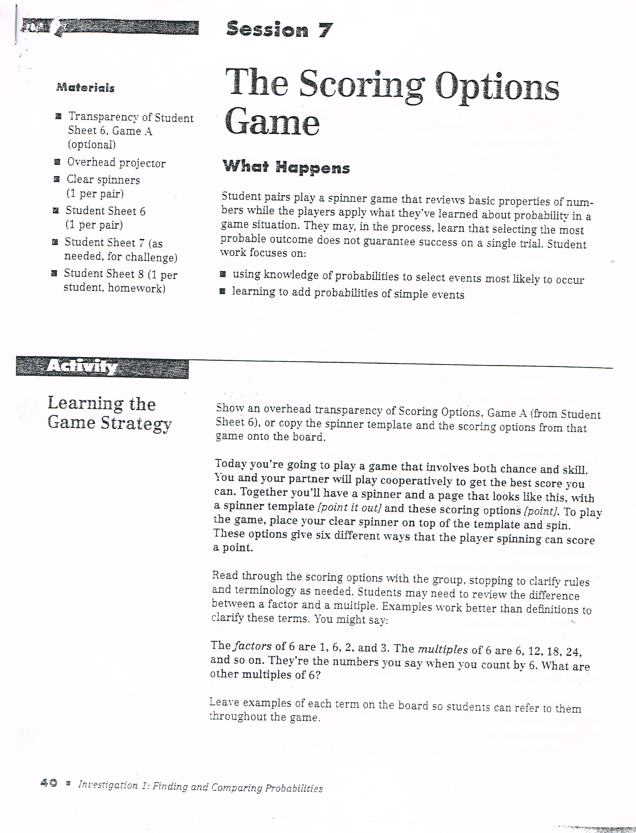

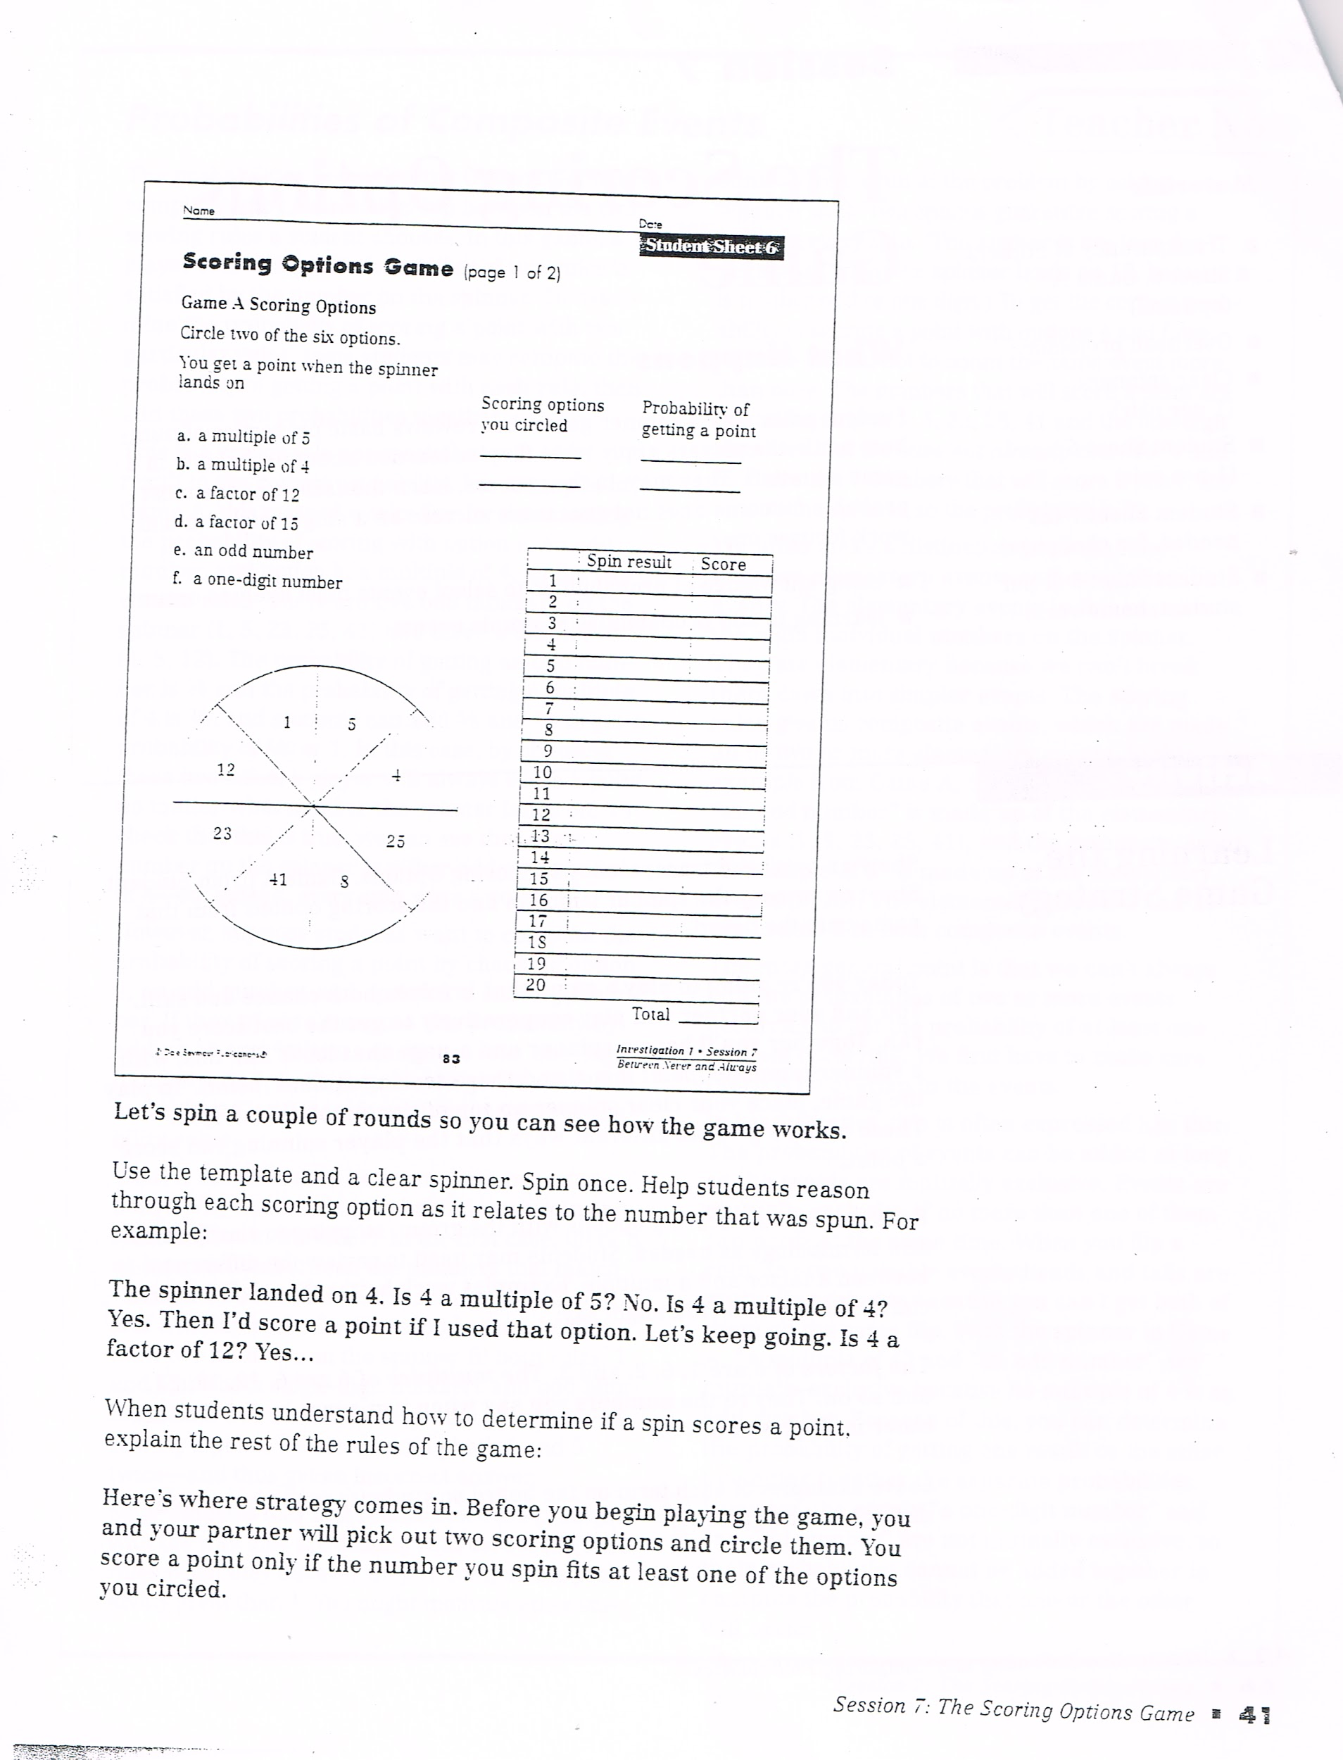

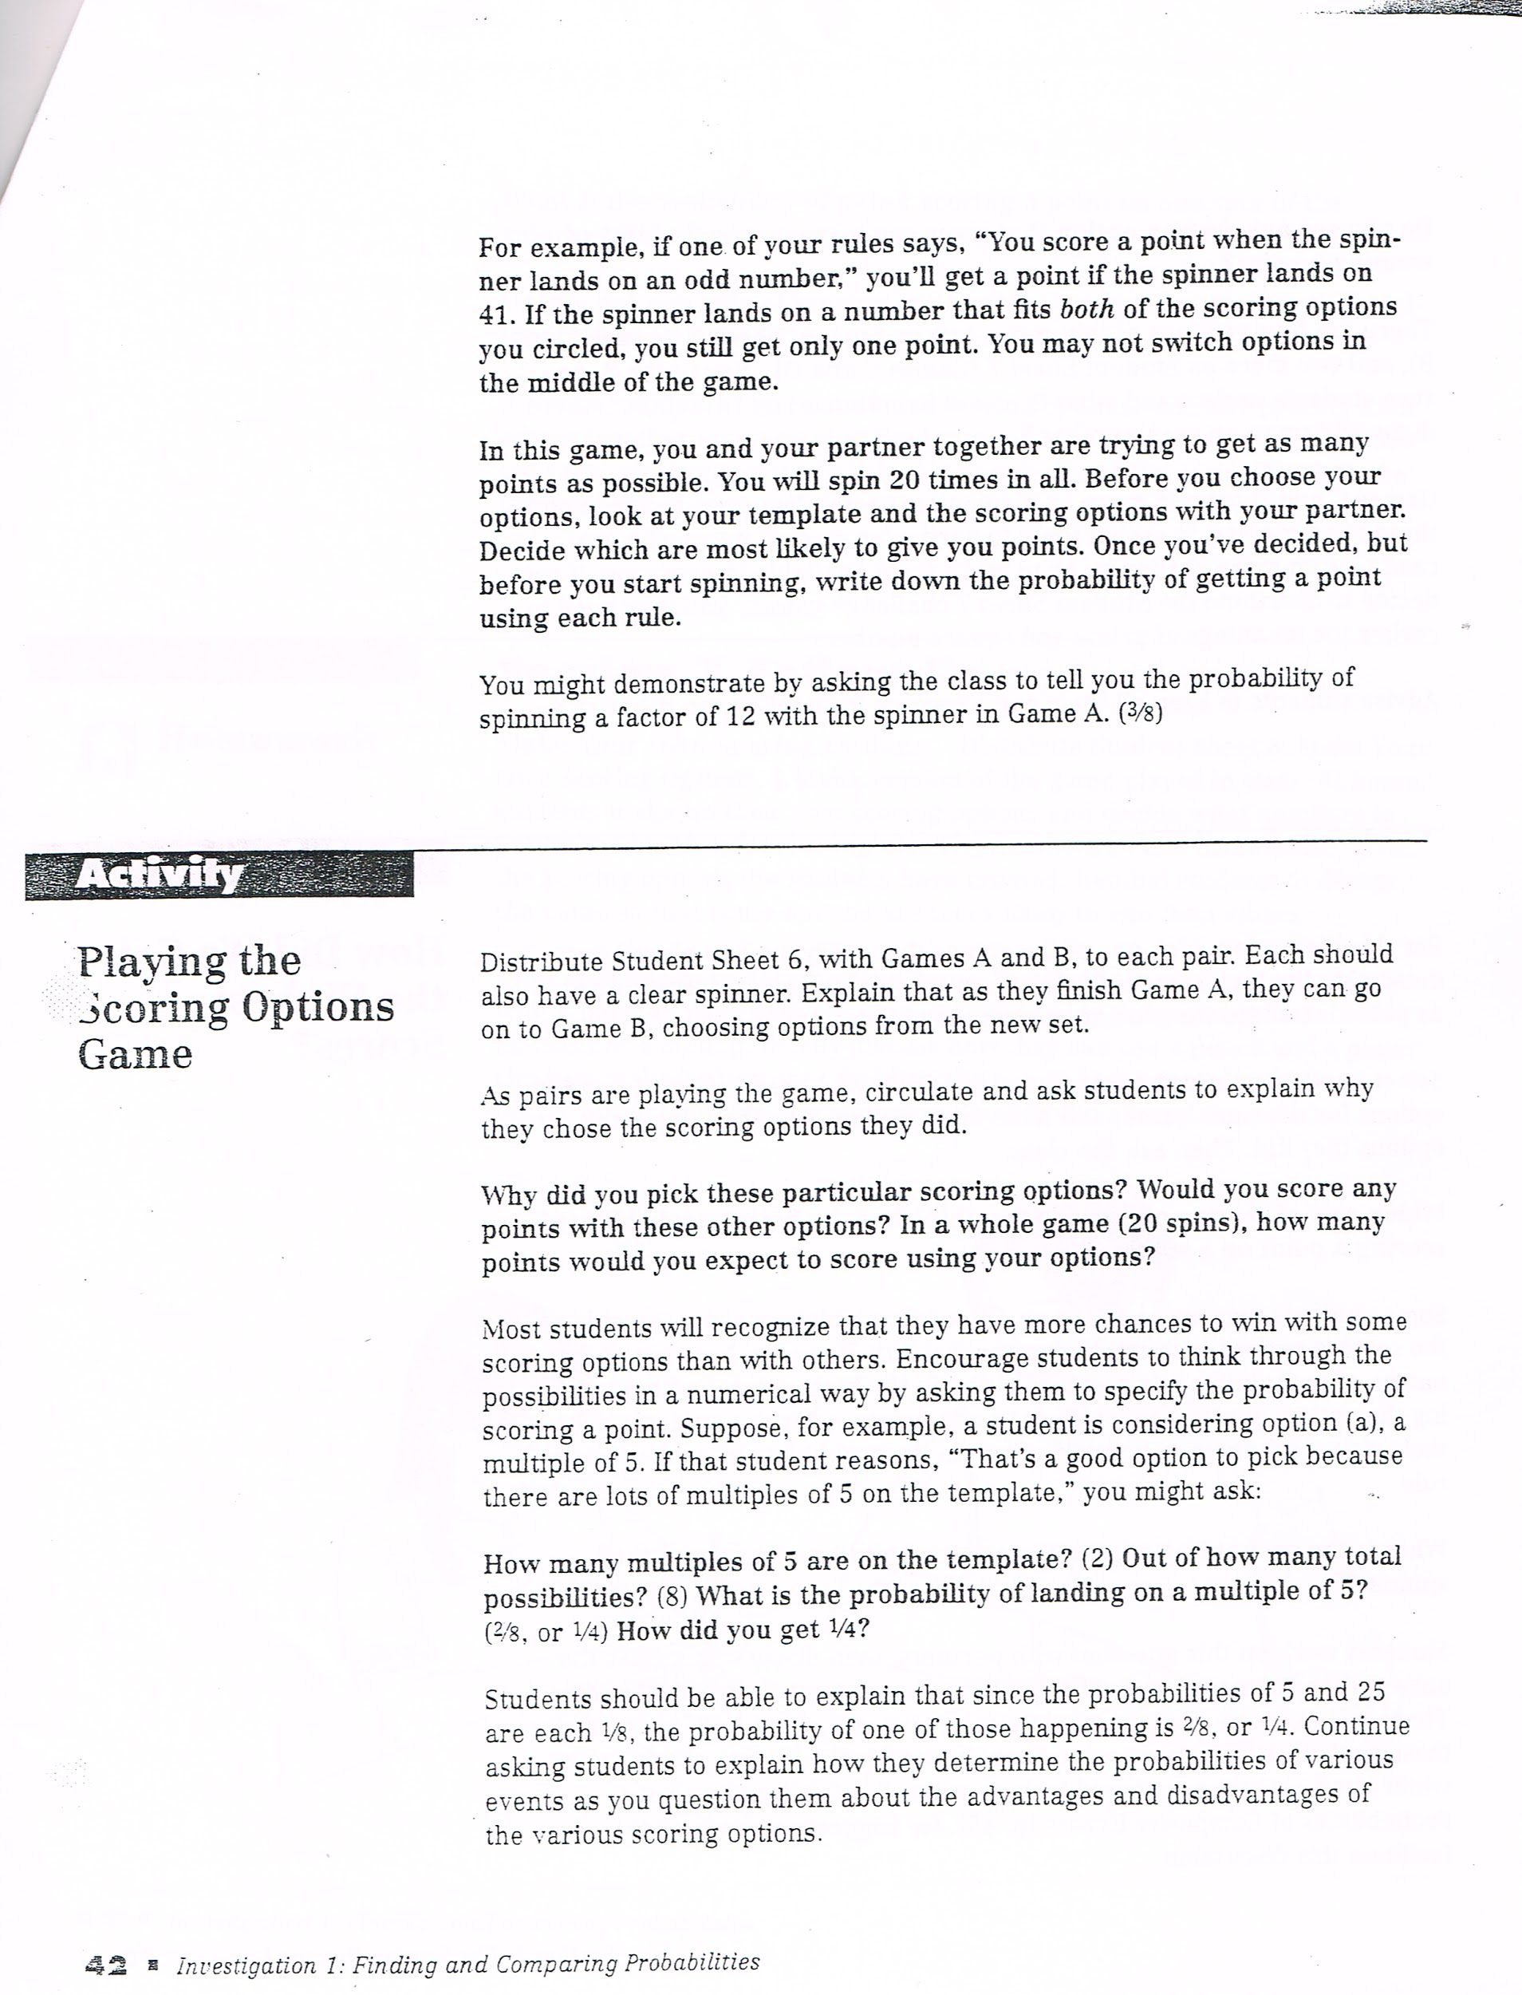

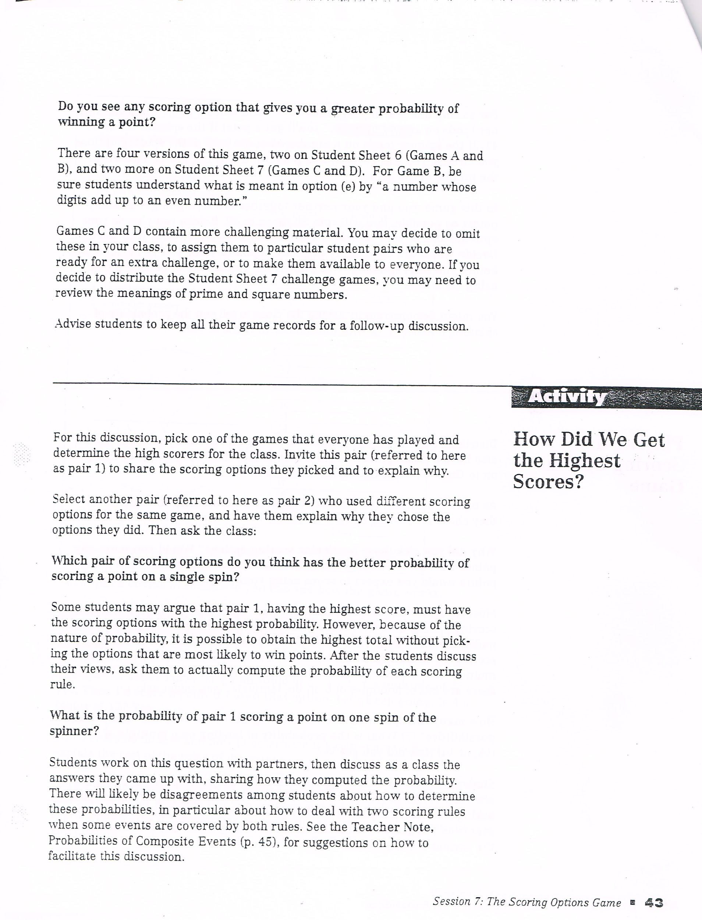

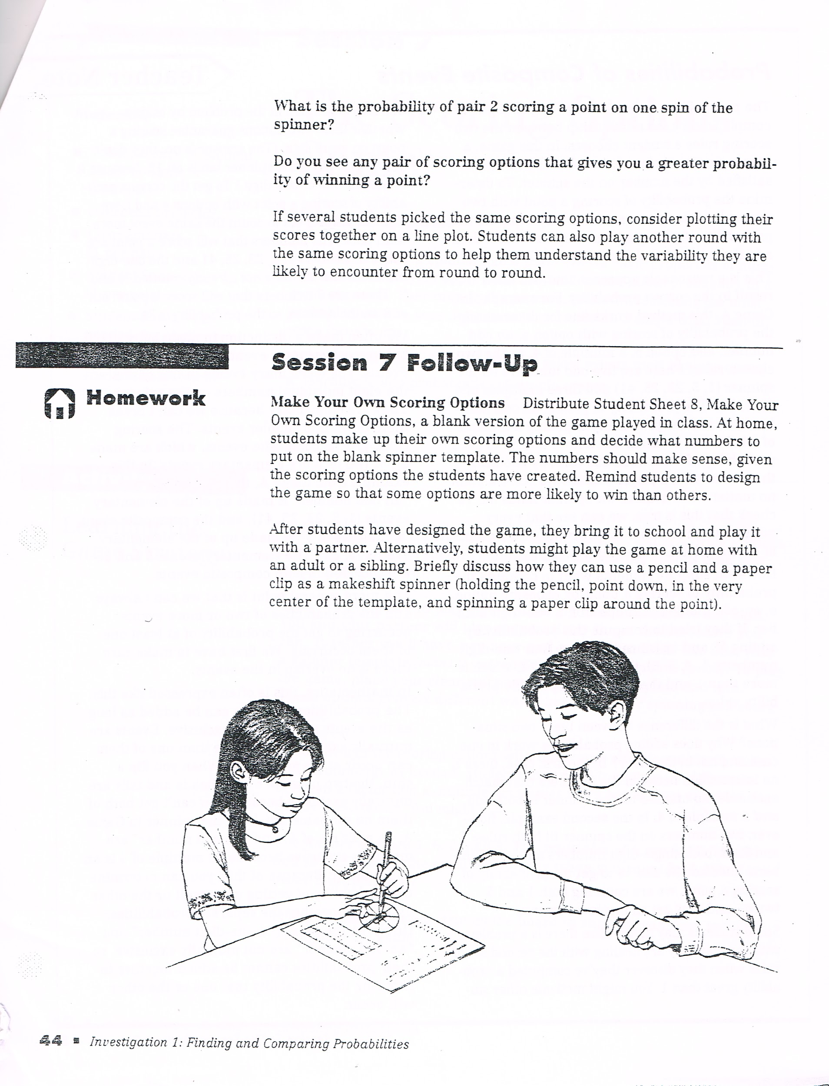

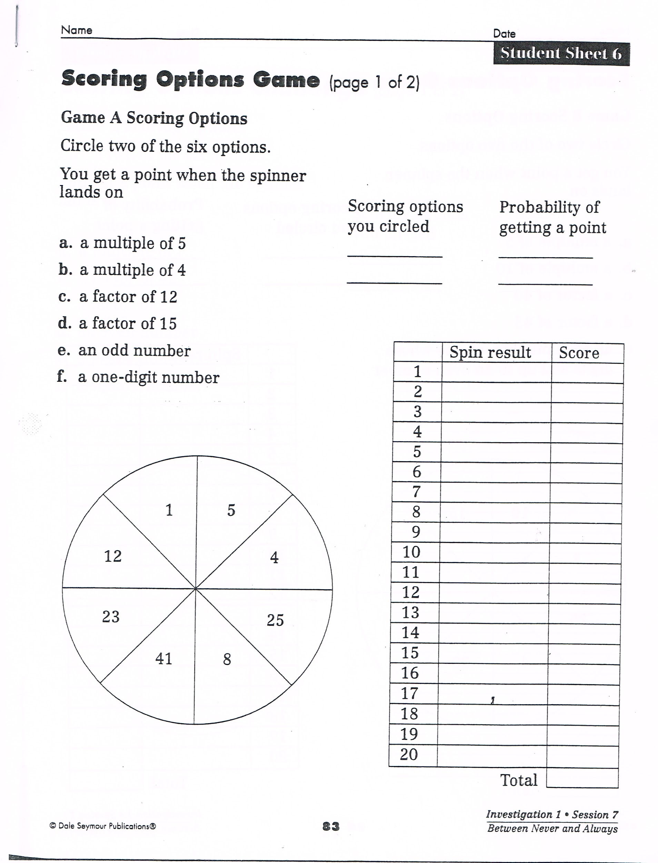

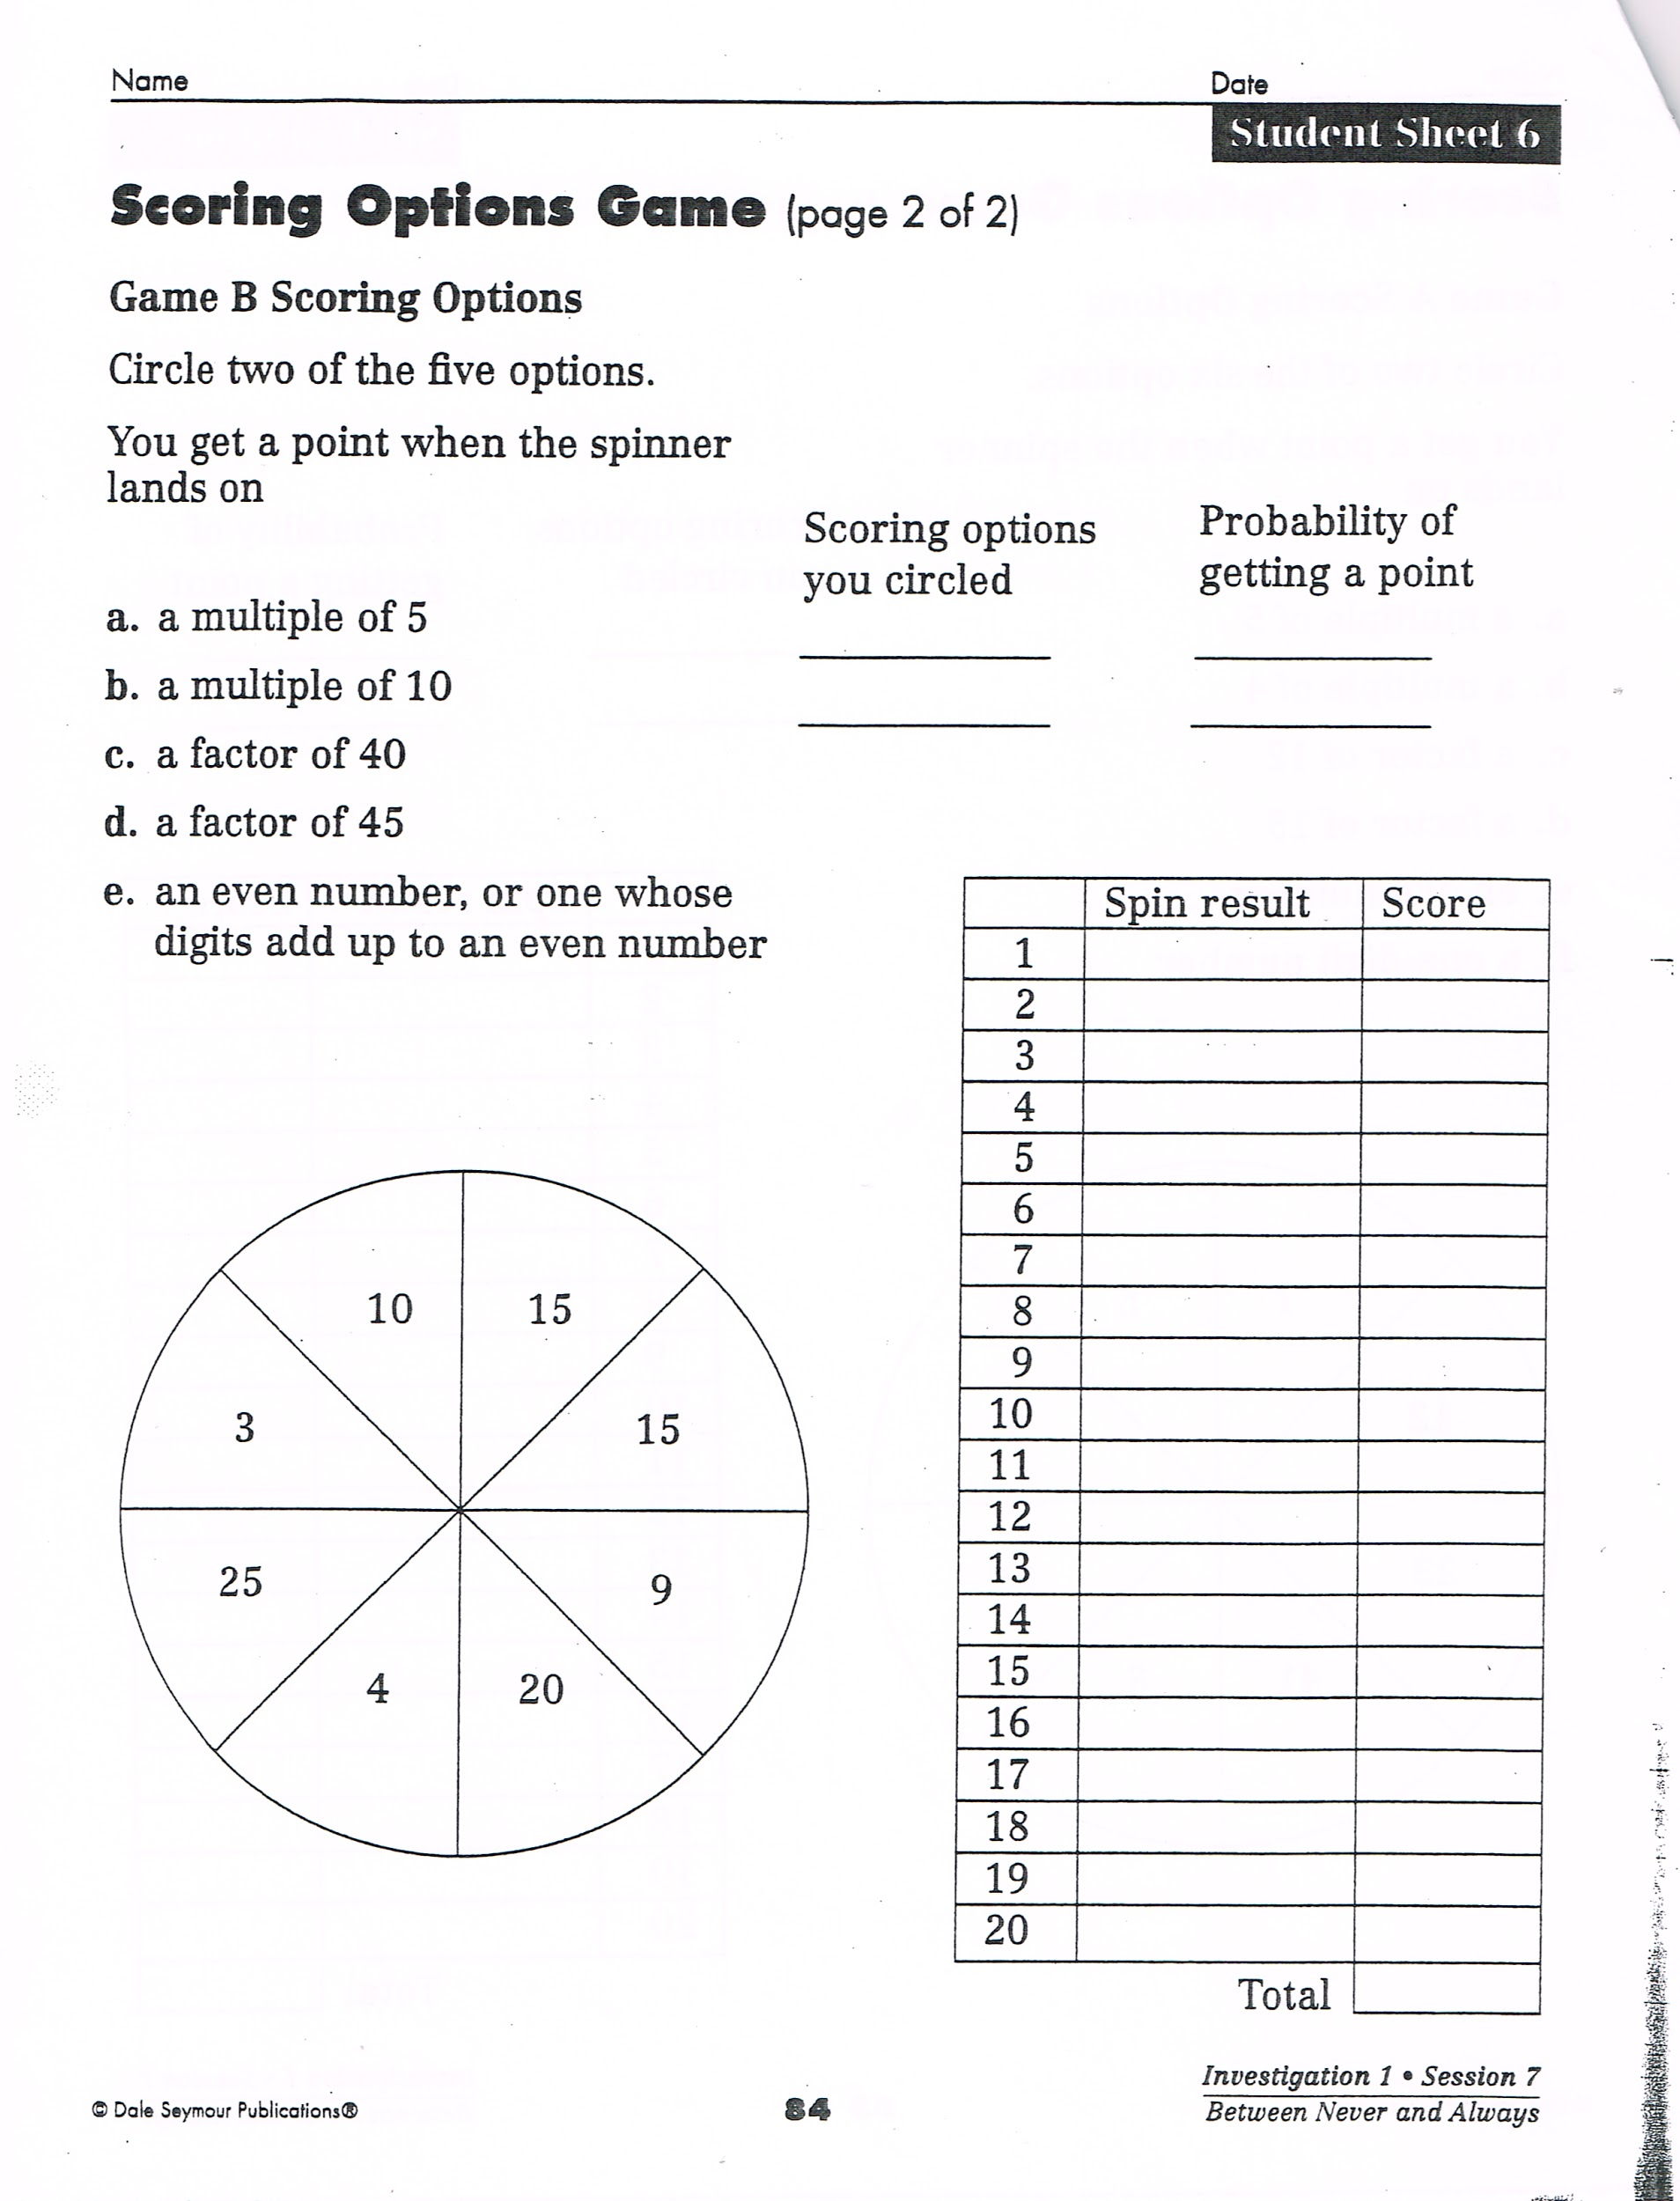

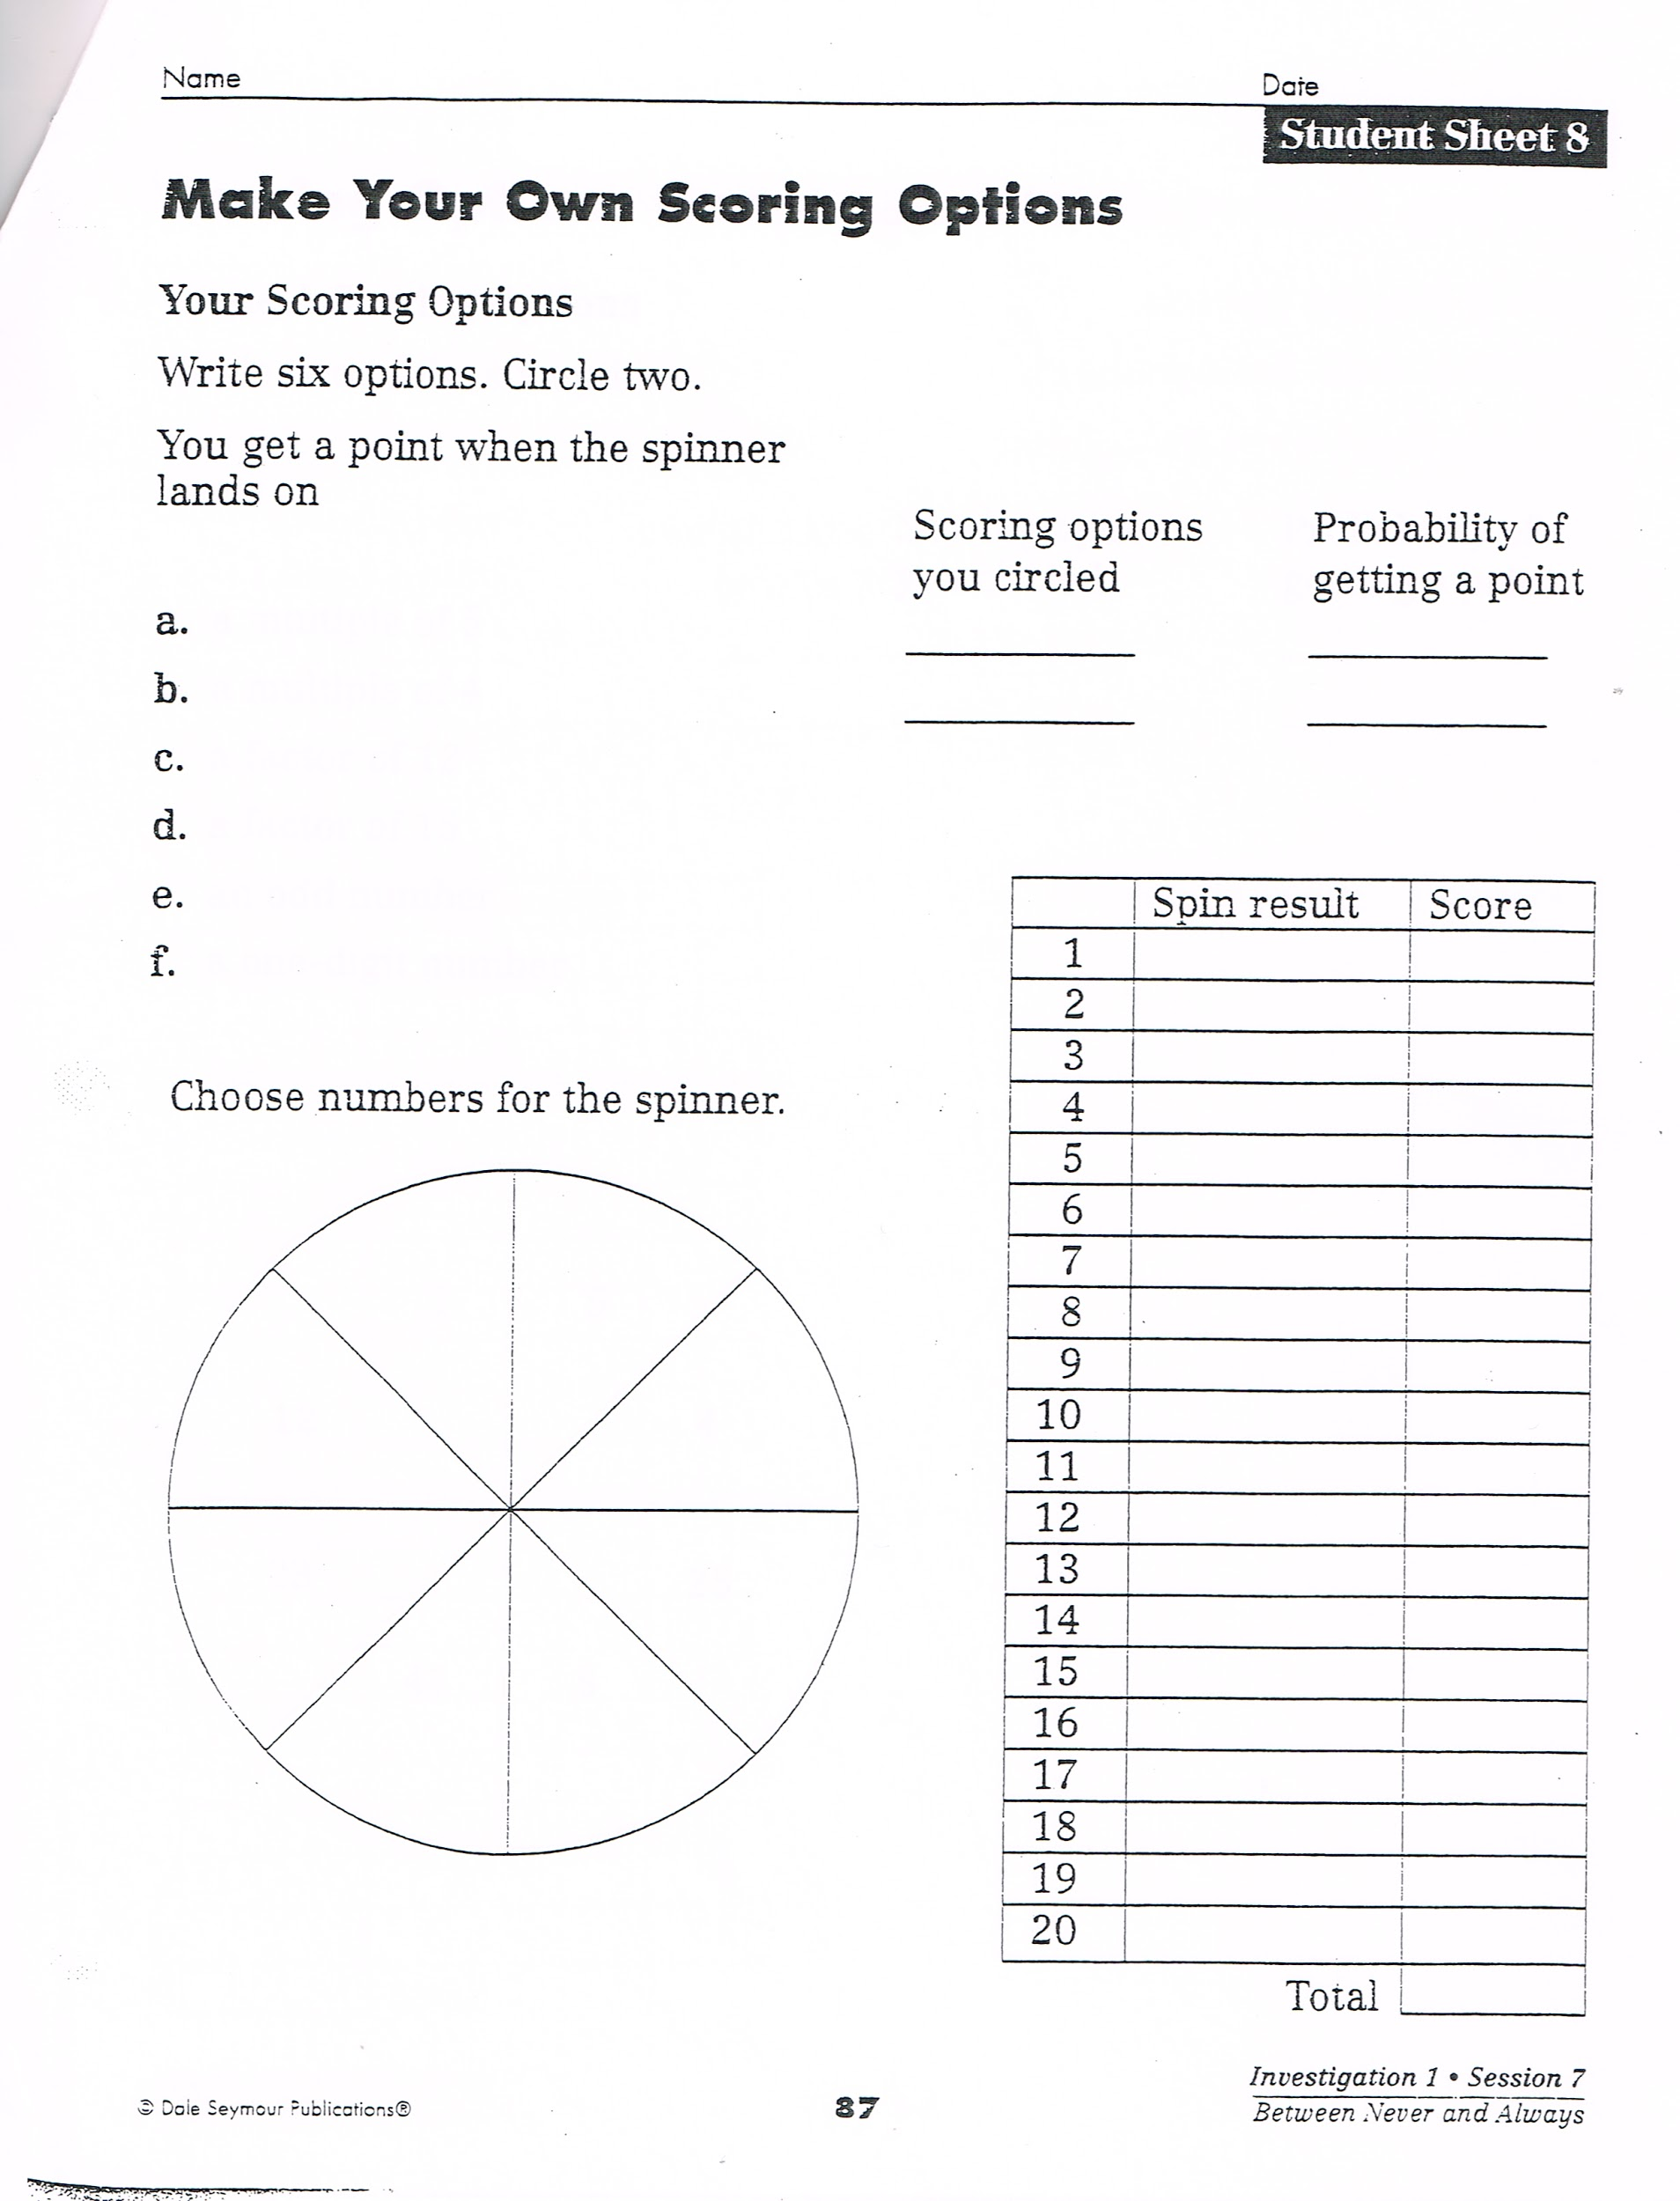

Lesson: Hey, It’s Not Fair
Day 14

Minnesota State Standard
3.4.1.1 - Collect, organize, display, and interpret data. Use labels and a variety of scales and units in displays.
4.4.1.1 Collect, organize, display and interpret data, including data collected over a period of time and data represented by fractions and decimals. Use tables, bar graphs, timelines and Venn diagrams to display data sets. The data may include fractions or decimals. Understand that spreadsheet tables and graphs can be used to display data.

Lesson Objective: Students will be able to decide if a game is fair or not.

Launch: Ask students, “Do you know what is fair or not?” After students have responded, ask them, “Are you sure?”. “Remember when we played that red, green, and blue colored block game, and we had a discussion about whether it was fair or not? Well, we are going to play another game today where you are going to decide if the game is fair or not. You will have to come up with some evidence to prove your decision.” For 3rd grade, this should be played later in the year, after they are starting to know their multiplication facts. For 4th grade, this can be played sooner in the year, after they have started reviewing their multiplication facts.

Material: Game sheet
Pencils
3 die per pair of students
Cup for shaking the dice
Calculator, optional
Tree diagram - to keep track of the dice rolled

Explore: Pair the students off. Give each of the partners the game sheet, a pencil and three dice. You want to tell students that they will need to decide who will be player A and player B before they learn all the rules of the game. They must also remain either A or B once they have started for both games. They may not change.

Have the students play the first game. Have them keep a record of the dice they roll for each play. This will be useful for discussing the results of each game and to help them see any patterns such as odds and evens and how they add up. (Note: Students could also make their own chart for the games in a math notebook. They could refer back for patterns in adding and multiplying.)

Have students play the second game. Have them make observations with their partners about what happened. Did they see any patterns? Ask if they thought the game was fair.

Game 1 - Rules
If the sum of the three numbers is odd, Player A gets a point.
If the sum of the three numbers is even, Player B gets a point.
The winner is the one with the most points at the end.

Game 2 - Rules
If the product is odd, Player A gets a point.
If the product is even, Player B gets a point.
Optional, calculator for finding the product only.
The winner is the one with the most points at the end.

Table for Game 1:
Die 1 | Die 2 | Die 3 | Sum

Table for Game 2

Die 1 | Die 2 | Die 3 | Product

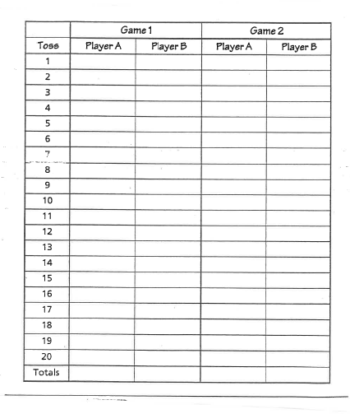
Share: As students finish each game and can look at their tables where they kept track of their results, have a discussion as to what they think happened. Have them talk about if the games are fair or not. Why do they think they are, or are not? Share with the whole class as to what they think would be better. Could they improve the “fairness” of the game? Ask if they want to play again but they would have to remain either A or B, whichever they had chosen at the beginning.

Summarize: Tell students they decided whether a game was fair or not based on their experiences with playing a game and through analyzing the data.

Lesson: Median and Mode
Day 15 & 16

Minnesota State Standard
3.4.1.1 - Collect, organize, display, and interpret data. Use labels and a variety of scales and units in displays.
4.4.1.1 Collect, organize, display and interpret data, including data collected over a period of time and data represented by fractions and decimals. Use tables, bar graphs, timelines and Venn diagrams to display data sets. The data may include fractions or decimals. Understand that spreadsheet tables and graphs can be used to display data.

Lesson Objective: Students will use frequency tables to find the mean, median and the mode of data sets.

Launch: (This lesson is for a two day period. It will also have occurred after several lessons that mode, median, and mean have already been discussed, worked with, and analyzed.) Play the song “Mode, Median, and Mean. Act out who is “Mode?” Ex. “Hi, I’m mode and I’m the most popular.” Median, Median, Median it’s the middle, middle, middle number. Let’s have fun learning these math words.

Materials: numbered index cards, use double digits, repeat some
2 - 8-½ by 11” papers, one labeled smallest, the other labeled largest

Explore: Part One: Give students a numbered index card. Talk about what the numbers might represent. Ask the students to stand in a line. As you are facing them, put the sign with the word smallest to the left and the sign with the word largest to the right. Tell students they are going to line themselves up from the smallest to the largest. Tell them they may only move based on comparisons with the person standing next to them. They may not wander around comparing with anyone at random. If they have the same number, children will stack up. They will look like a bar graph made of people. After they are done, ask students which numbers occurred the most frequent, least frequent, and
not represented at all. Ask students to figure out the median, the mode, and how they would calculate the mean.

Materials: Sticky notes
Calculators
Pencils
Frequency Table Class Note Pad
Frequency Table (copy enough for each student)

Part Two: To determine the class waist-to-floor measurements have students work in groups of three. They will measure each other’s waist-to-floor measurement and record on individual sticky notes. Demonstrate what you want the students to do. Draw a line plot on the whiteboard, start numbering from about 25 to about 35. Have students put their sticky notes where they belong on the line plot. Collect the data and place it on a Class Data Pad. Write the numbers from smallest to largest in the first column. Have students add a tally where their measurement would correspond in the second column. Once all the tallies are on, the teacher needs to make sure all the tallies are on the pad. Count up the number of tallies for each measurement. In the third column of the class pad, write the number on the frequency table that shows the tally set. “A frequency table can be used to determine how often (or the number of times) an event or value occurs.”

Frequency
Waist-to-Floor  Measurement (In.) | Tallies | Number
27 | // | 2
28 |  | 0
29 | ///// | 5
30 | ///// /// | 8
31 | ///// // | 7
32 | //// | 4

Have students make the same kind of table in their math notebooks or make a version of this table for the students to use to glue into their notebook. They can add the information as you go along in the lesson. Students should still be in their groups. Ask the students the following questions to put into their notebooks. Remind students to label their answers with the unit they were using to measure. As a group, they will determine the answers to the questions. They will use a calculator to determine the mean.

- What is the median (middle value) of the measurements?
- What is the mean (average) of the measurements? Students may use calculators.
- What is the mode (value that occurs the most) of the measurements?
- Have students record the range (difference between the minimum and maximum).

Share: After the students have finished their work, have them come together as a whole group to share results and the strategies they used to determine the answers. Have students share how they found the median, mean, and mode.
Some examples of follow up questions to make sure are covered as the students share:
- How did you find the median using the frequency table?
- Did anyone list the information in order from smallest to largest to find the median?
- What did you get for the mean? Compare the mean to the median. What did you find out?
- What did everyone get for the mode?
- How does that compare to the median?

Part Three: This should be completed after the whole group sharing. Have students graph the information using a bar graph. Check to see they are accurate in their recording as they complete it. Remind them to label all parts of the graph. Tell them they can use crayons or colored pencils to fill in the graph. When they are done, have students share their graphs with their work partners. Ask if using a graph helps them to find the mode of the number set.

Summarize: Tell students they created and used a frequency table to find the mode, mean, and the median of a set of values.

Source: Bell, Max, et. al. Everyday Mathematics. Chicago:Wright Group/McGraw-Hill, 2007. Lesson 10.9, pp. 853-857, Student’s Math Journal, p. 352.

